**Cloud IAM**

So what is identity access management? It is a way of identifying who can do what, on which resource. The who can be a person, group, or application. The what refers to specific privileges or actions, and the resource could be any GCP service. For example I could give you the privilege or role of compute viewer. This provides you with read-only access to get enlist Compute Engine resources without being able to read the data stored on them. Cloud IAM is composed of different objects as shown on this slide. We are going to cover each of these in this module.

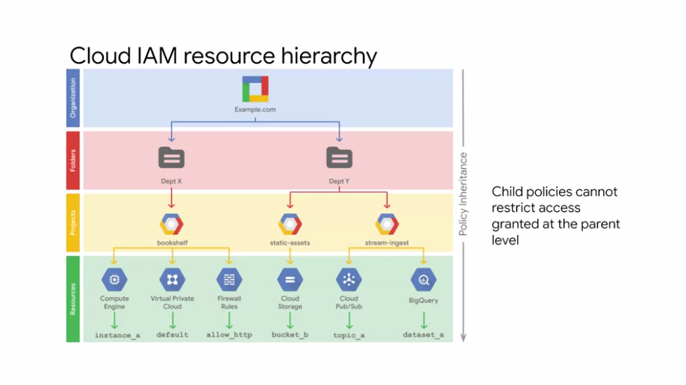

To get a better understanding of where these fit in, let's look at the Cloud IAM resource hierarchy. Google Cloud Platform resources are organized hierarchically as shown in this tree structure.

* The **organization** node is the root node in this hierarchy.
* **Folders** are the children of the organization.
* **Projects** are the children of the folders, and the individual **resources** are the children of projects. Each resource has exactly one parent.

Cloud IAM allows you to set policies at all of these levels. Where a policy contains a set of roles, and role members. Let me go through each of the levels from top to bottom, because resources inherit policies from their parent.

* The organization resource represents your company. Cloud IAM roles granted at this level are inherited by all resources under the organization.
* The folder resource could represent your department. Cloud IAM roles granted at this level are inherited by all resources that the folder contains.
* Projects represent a trust boundary within your company. Services within the same project have a default level of trust.

The Cloud IAM policy hierarchy always follows the same path as the GCP resource hierarchy, which means that if you change the resource hierarchy the policy hierarchy also changes. For example, moving a project into a different organization will update the projects Cloud IAM policy to inherit from the new organizations Cloud IAM policy. Also, child policies cannot restrict access granted at the parent level. For example, if I grant you that editor role for department X, and I grant you the viewer role at the Bookshelf project level, you still have the editor role for that project. Therefore, it is a best practice to follow the principle of least privilege. The principle applies to identities, roles, and resources. Always select the smallest scope that's necessary for the task in order to reduce your exposure to risk.

**Organization**

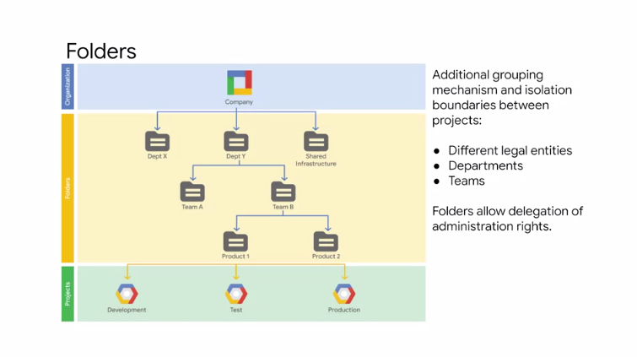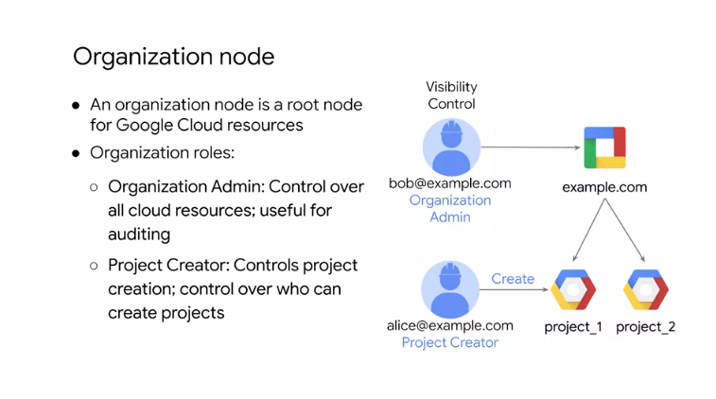

Let's learn more about the organization node. As I mentioned earlier, the organization resource is the root node in the GCP resource hierarchy. This node has many roles like the organization admin. The organization admin provides a user like Bob with access to administer all resources belonging to his organization, which is useful for auditing. There is also a project creator role, which allows a user like Alice to create projects within her organization. I am showing the project creator role here because it can also be applied at the organization level which would then be inherited by all the projects within the organization.

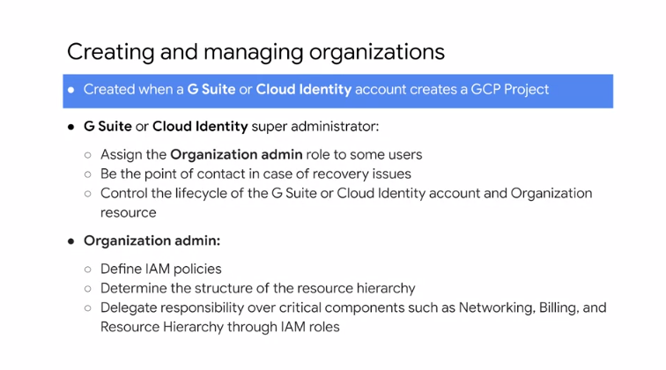

The organization resource is closely associated with a G Suite or Cloud Identity account. When a user with a G Suite or Cloud Identity account creates a GCP project, an organization resource is automatically provisioned for them. Then Google Cloud communicates its availability to the G Suite or Cloud Identity super admins. These super admin accounts should be used very carefully because they have a lot of control over your organization and all the resources underneath it. The G Suite or Cloud Identity super administrators and the GCP organization admin are key roles during the setup process and for lifecycle control for the organization resource. The two roles are generally assigned to different users or groups, although this depends on the organization's structure and needs. In the context of GCP organization setup, the G Suite or Cloud Identity super administrator responsibilities are; assign the organization admin role to some users, be a point of contact in case of recovery issues, control the lifecycle of the G Suite or Cloud Identity account and organization resource. The responsibilities of the organization admin role are; define IAM policies, determined the structure of the resource hierarchy, delegate responsibility over critical components such as networking, billing, and resource hierarchy through IAM roles. Following the principle of least privilege, this role does not include the permission to perform other actions such as creating folders. To get these permissions, an organization admin must assign additional roles to their account for. For more information about creating and managing organizations, see the how-to guide in the links section of this video. Let's talk more about folders because they can be viewed as sub organizations within the organization. Folders provide an additional grouping mechanism and isolation boundary between projects. Folders can be used to model different legal entities, departments, and teams within a company. For example, a first level of folders can be used to represent the main departments in your organization like departments X and Y. Because folders can contain projects and other folders, each folder could then include other sub folders to represent different teams like teams A and B. Each team folder could contain additional sub folders to represent different applications like products 1 and 2. Folders allow delegation of administration rights. So for example, each head of a department can be granted full ownership of all GCP resources that belong to their department. Similarly, access to resources can be limited by folder. So users in one department can only access and create GCP resources within that folder.

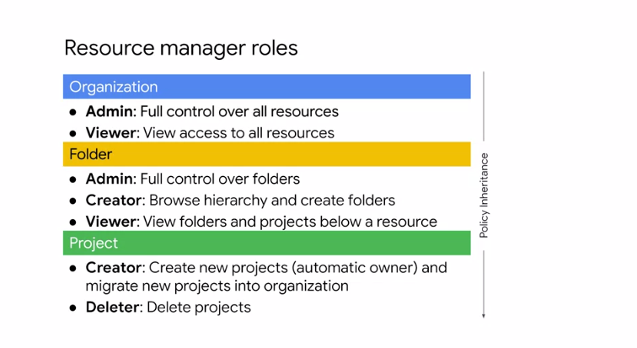

Let's look at some other resource manager roles while remembering that policies are inherited from top to bottom. The organization node also has a viewer role that grants view access to all resources within an organization. The folder node has multiple roles that mimic the organizational roles but are applied to resources within a folder. There is an Admin role that provides full control over folders, a creator role to browse the hierarchy and create folders, and a viewer role to view folders and projects below a resource. Similarly, for projects, there is a creator role that allows a user to create new projects making that user automatically the owner. There is also a project deleter role that grants deletion privileges for projects.

**Roles**

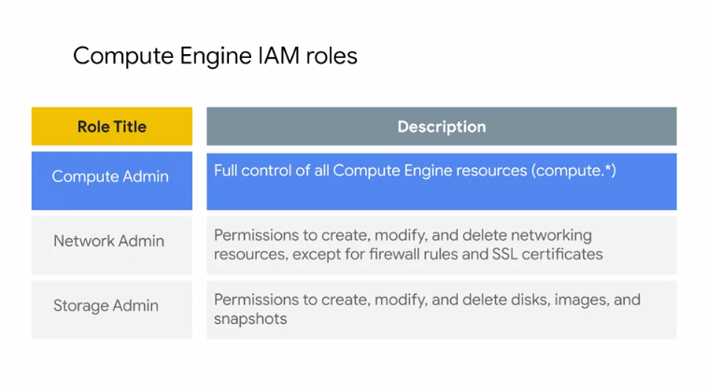

Let's talk more about roles which define the can do what on which resource part of Cloud IAM.

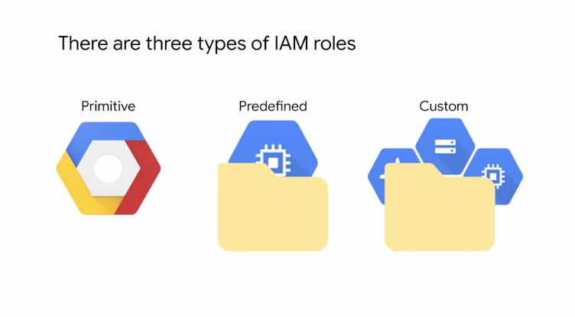

There are three types of roles in Cloud IAM; Primitive roles, predefined roles, and custom roles. Primitive roles are the original roles that were available in the GCP console, but they are broad. You apply them to a GCP project and they affect all resources in that project.

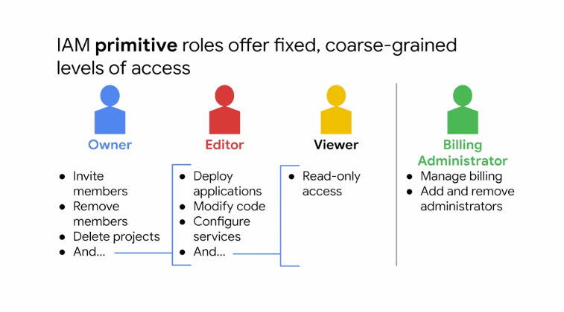

In other words, IAM **primitive** roles are for fixed, coarse-grained levels of access. The permanent roles are the owner, editor, and viewer roles. The owner has full administrative access. This includes the ability to add and remove members and delete projects. The editor role has modify and delete access. This allows a developer to deploy applications and modify it or configure its resources. The viewer role has read only access. All of these roles are concentric. That is, the owner role includes the permissions of the editor role, and the editor role includes the permissions of the viewer role. There is also a billing administrator role to manage billing an add or remove administrators without the right to change the resources in the project. Each project can have multiple owners, editors, viewers, and billing administrators.

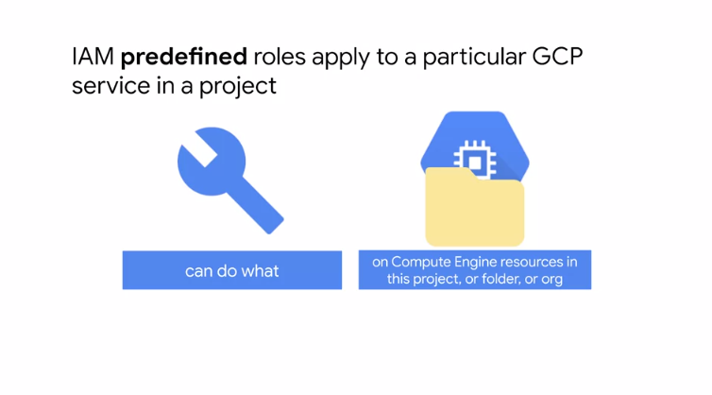

GCP services offer their own set of **predefined** roles and they define where those roles can be applied. This provides members with granular access to specific GCP resources and prevents unwanted access to other resources. These roles are collections of permissions because to do any meaningful operations, you usually need more than one permission. For example, as shown here a group of users is granted the instance admin role on Project A. This provides the users of that group with all the Compute Engine permissions listed on the right and more. Grouping these permissions into a role makes them easier to manage. The permissions themselves are classes and methods in the APIs.

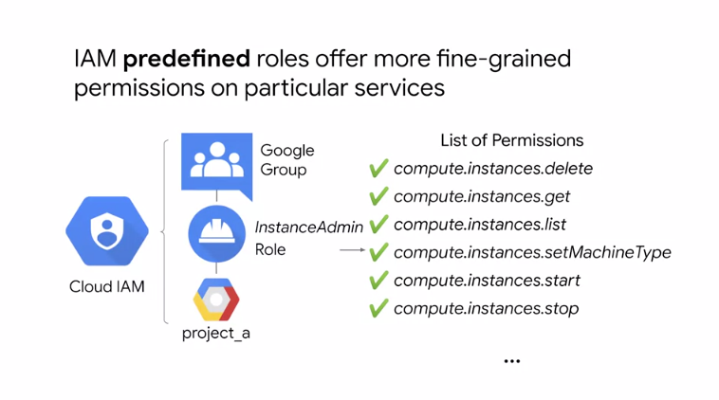

For example, compute.instances.start can be broken down into the service, resource, and verb. That means that this permission is used to start and stop Compute Engine instance. These permissions usually align with the actions corresponding REST API. Compute Engine has several predefined IAM roles.

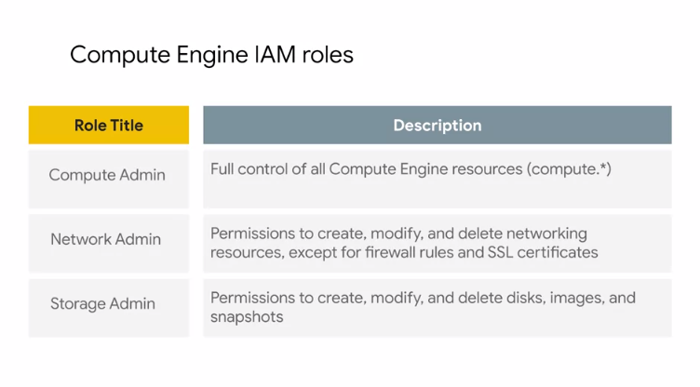

Let's look at three of those.

* The Compute Admin role provides full control of all Compute Engine resources. This includes all permissions that start with Compute which means that every action for any type of Compute Engine resource is permitted.
* The Network Admin role contains permissions to create, modify, and delete networking resources except for firewall rules and SSL certificates. In other words, the network admin role allows read-only access to firewall rules, SSL certificates, and instances to view their ephemeral IP addresses.
* The Storage Admin role contains permissions to create, modify, and delete disks, images and snapshots.

For example, if your company has someone who manages project images and you don't want them to have the editor role on the project, grant their account the Storage Admin role on the project. For the full list of predefined roles for Compute Engine see the link section of this video. Now, roles are meant to represent abstract functions and are customized to align with real jobs.

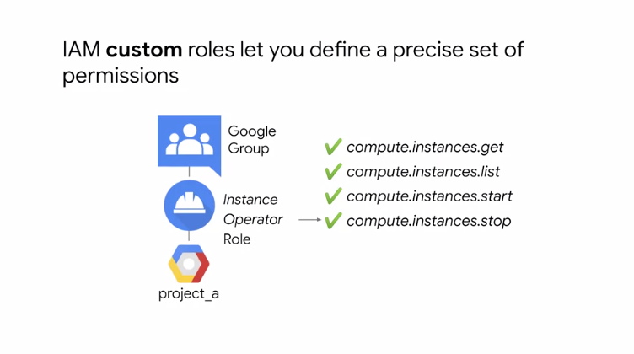

But what if one of those roles does not have enough permissions or you need something even finer-grained? That's what **Custom** Roles permit. A lot of companies use the least privileged model in which each person in your organization is given the minimal amount of privilege needed to do their job. Let's say you want to define an instance operator role to allow some users to start and stop Compute Engine virtual machines, but not reconfigure them. Custom Roles allow you to do that.

**Members**

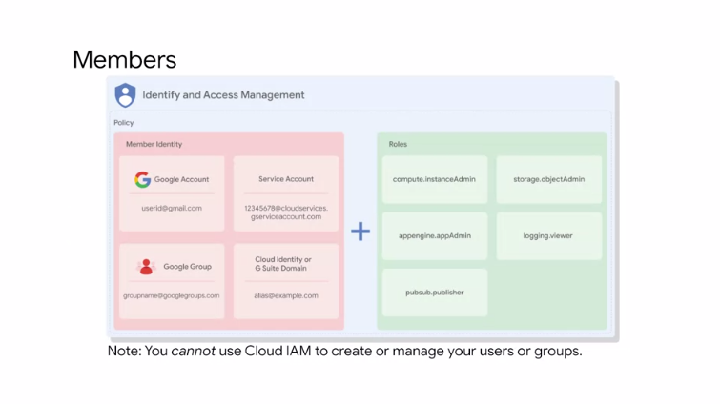

Let's talk more about members, which define the who part, of who can do what, on which resource. There are five different types of members. Google Accounts, Service Accounts, Google Groups, G Suite Domains, and Cloud Identity Domains.

* A Google Account represents a developer, an administrator or any other person who interacts with GCP. Any email address that is associated with a Google Account can be an identity, including gmail.com or other domains. New users can sign up for a Google Account, by going to the Google Account sign-up page, without receiving mail through Gmail.
* A Service Account is an account that belongs to your application, instead of to an individual end user. When you run code that is hosted on GCP, you specify the account that the code should run as. You can create as many Service Accounts as needed to represent the different logical components of your application.
* A Google Group is a named collection of Google Accounts and Service Accounts. Every group has a unique email address that is associated with the group. Google Groups are a convenient way to apply an access policy to a collection of users. You can grant and change access controls for a whole group at once, instead of granting or changing access controls one at a time, for individual users or Service Accounts.
* G Suite Domains, represent your organization's Internet domain name, such as example.com. When you add a user to your G Suite Domain, a new Google Account is created for the user inside this virtual group such as, username@example.com. GCP customers who are not G Suite customers can get the same capabilities through Cloud Identity.
* Cloud Identity, lets you manage users in groups using the Google Admin Console. But you do not pay for or receive G Suite's collaboration products such as Gmail, Docs, Drive, and Calendar. Cloud Identity is available and free in Premium Editions. The Premium Edition adds capabilities for mobile device management.

Now it's important to note, that you can not use Cloud IAM to create or manage your users or groups. Instead, you can use Cloud Identity or G Suite to create and manage users. What if you already have a different corporate directory? How can you get your users and groups into GCP?

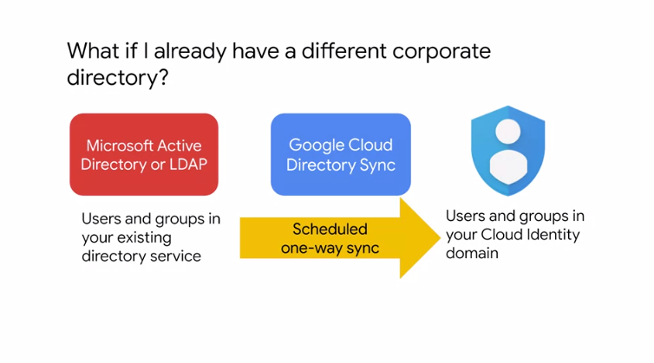

Using Google Cloud Directory Sync, your administrators can log in and manage GCP resources, using the same usernames and passwords they already use. This tool synchronizes users and groups, from your existing Active Directory or LDAP system, with the users and groups in your Cloud Identity Domain. The synchronization is one way only, which means that no information in your Active Directory or LDAP map is modified. Google Cloud Directory Sync, is designed to run scheduled synchronizations without supervision, after its synchronization, rules are set up.

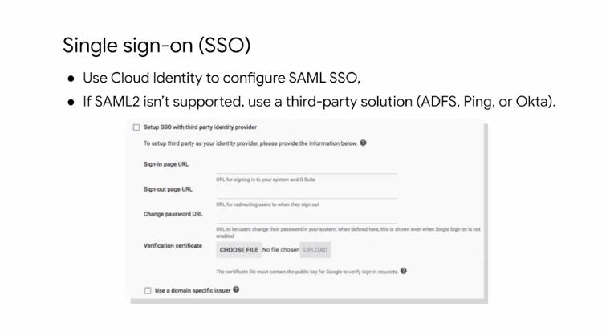

GCP also provides Single Sign-On Authentication. If you have your identity system, you can continue using your own system, and processes with SSL configured. When user authentication is required, google will redirect to your system. If the user is authenticated in your system, access to Google Cloud Platform is given. Otherwise, the user is prompted to sign in. This allows you to also revoke access to GCP. If your existing authentication system support SAML2, SSO configuration, is as simple as three links and a certificate, as shown on this slide. Otherwise, you can use a third-party solution like ADFS, Ping or Okta. For more information about using your existing Identity Management System, see the link section of this video.

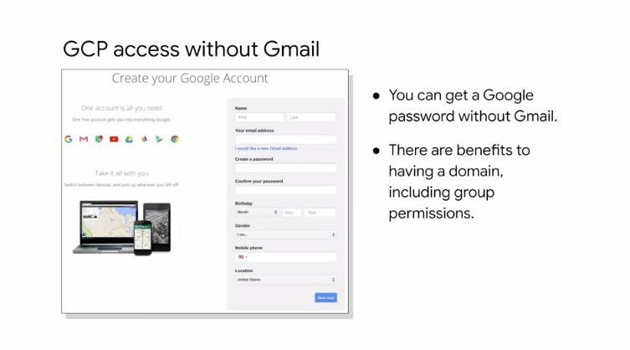

Also, if you want to use a Google account, but are not interested in receiving mail through Gmail, you can still create an account without Gmail. For more information about this, see the link section of this video.

**Service Accounts**

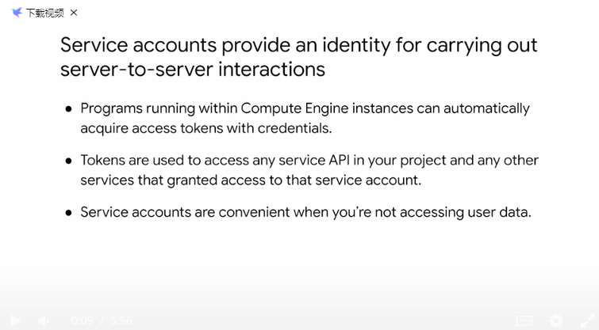

As I mentioned earlier, another type of member is a service account. A service account is an account that belongs to your application instead of to an individual end user. This provides an identity for carrying out server-to-server interactions in a project without supplying user credentials. For example, if you write an application that interacts with Google Cloud Storage, it must first authenticate to either the Google Cloud Storage XML API or JSON API. You can enable service accounts and grant read write access to the account on the instance where you plan to run your application, then program the application to obtain credentials from the service account. Your application authenticate seamlessly to the API without embedding any secret keys or credentials in your instance, image, or application code.

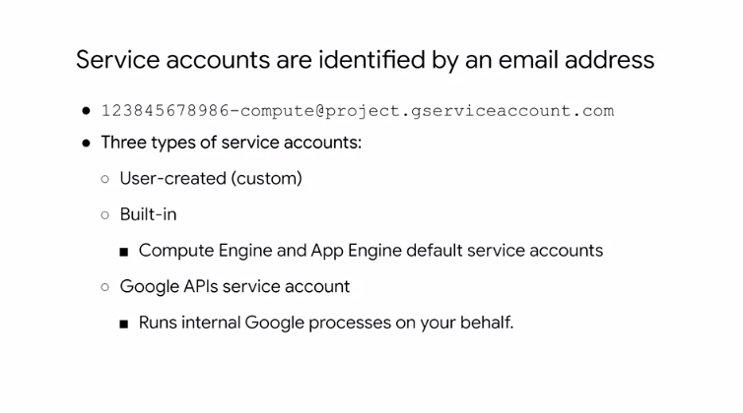

Service accounts are identified by an email address, like the example shown here. There are three types of service accounts, user-created or custom, built-in, and Google APIs service accounts. By default, all projects come with the built-in Compute Engine default service account. Apart from the default service account, all projects come with the Google Cloud Platform APIs service account, identifiable by the email, project-number@cloudservices.gserviceaccount.com. This is the service account designed specifically to run internal Google processes on your behalf, and it is automatically granted the editor role on your project. Alternatively, you can also start an instance with accustomed service account. Custom service accounts provide more flexibility than the default service account, but they require more management from you. You can create as many custom service accounts as you need, assign any arbitrary access scopes, or Cloud IAM roles to them, and assign the service accounts to any Virtual Machine instance. Let's talk more about the default Compute Engine service account.

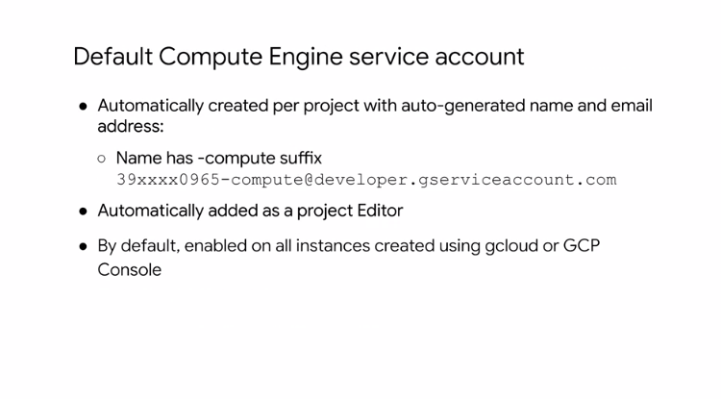

As I mentioned, this account is automatically created per project. This account is identifiable by the email, project-number-compute@developer.gserviceaccount.com, and it is automatically granted the editor role on a project. When you start a new instance using GCloud, the default service account is enabled on that instance. You can override this behavior by specifying another service account or by disabling service accounts for the instance.

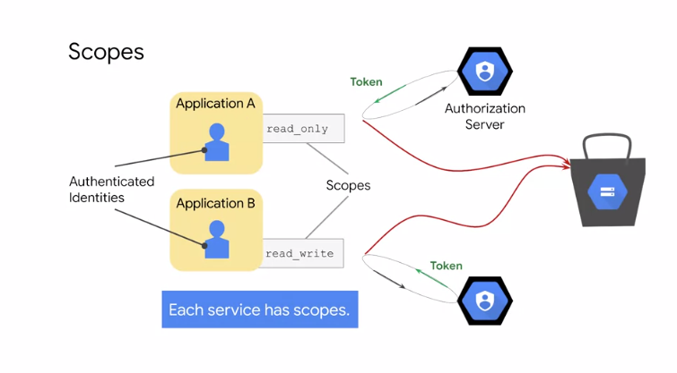

Now, authorization is the process of determining what permissions an authenticated identity has on a set of specified resources. Scopes are used to determine whether an authenticated identity is authorized. In the example shown here, applications A and B contain authenticated identities or service accounts. Let's assume that both applications want to use a Cloud Storage bucket. They each request access from the Google Authorization Server, and in return they receive an access token. Application A receives an access token with read-only scope, so it can only read from the Cloud Storage bucket. Application B in contrast, receives an access token with read-write scope, so it can read and modify data in the Cloud Storage bucket. Scopes can be customized when you create an instance using the default service account as shown in this screenshot. These scopes can be changed after an instance is created by stopping in. Access scopes are actually the legacy method of specifying permissions for your VM. Before the existence of IAM roles, access scopes were the only mechanism for granting permissions to service accounts. For user-created service accounts, use Cloud IAM roles instead to specify permissions. Another distinction between service accounts is that default service account support both primitive and predefined roles. But user-created service accounts only use predefined IAM roles.

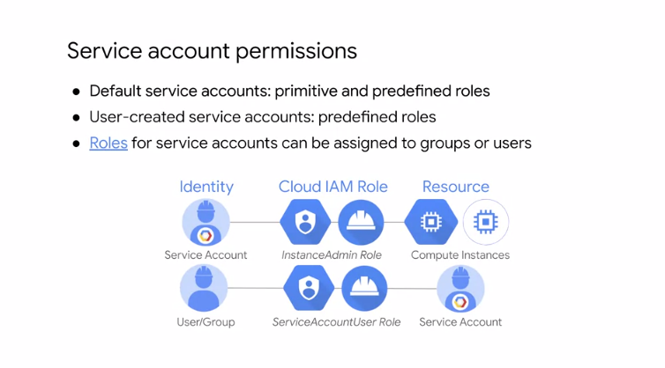

Now, roles for service accounts can also be assigned to groups or users. Let's look at the example shown on this slide. First, you created a service account that has the instance admin role, which has permissions to create, modify, and delete Virtual Machine instances and disks. Then, you treat this service account as the resource, and decide who can use it by providing users or a group with the service account user role. This allows those users to act as that service account to create, modify, and delete Virtual Machine instances and disks. Users who are service account users for a service account can access all the resources of the service account has access to. Therefore, be cautious when granting the service account user role to a user or group.

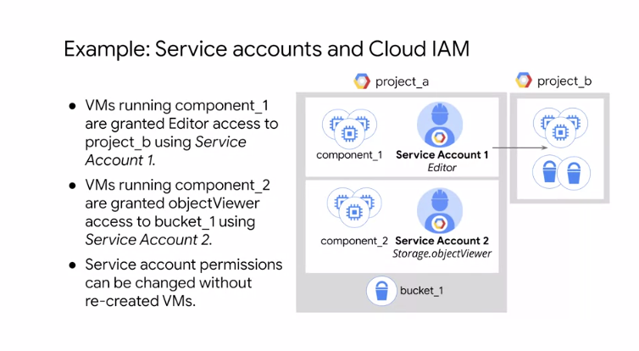

Here is another example. The VMs running component 1 are granted editor access to project B using Service Account 1. VMs running component 2 are granted object viewer access to bucket one using an isolated Service Account 2. This way you can scope permissions for VMs without recreating VMs. Essentially, Cloud IAM lets you slice a project into different microservices, each with access to different resources by creating service accounts to represent each one. You assign the service accounts to the VMs when they are created, and you don't have to ensure the credentials are being managed correctly because GCP manages security for you.

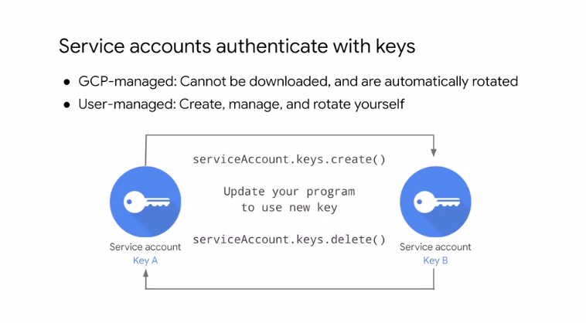

Now, you might ask, how are the service accounts authenticated? Although users require a username and password to authenticate, service accounts use keys. There are two types of service account keys: GCP-managed keys and user-managed keys. GCP-managed keys are used by GCP services, such as App Engine and Compute Engine. These keys cannot be downloaded, and are automatically rotated and used for a maximum of two weeks. User-managed keys are created, downloadable, and managed by users. When you create a new key pair, you download the private key, which is not retained by Google. With user-managed keys, you are responsible for security of the private key and other management operations such as key rotation, which is illustrated on this slide.

**Cloud IAM best practices**

Let's talk about some Cloud IAM best practices to help you apply the concepts you just learned in your day-to-day work.

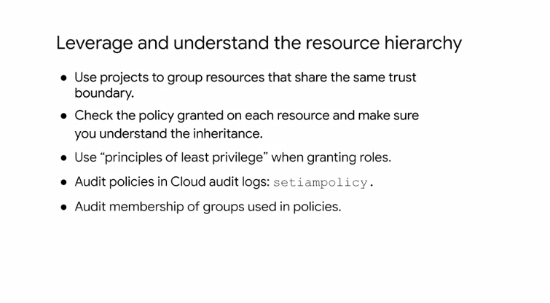

First, leverage and understand the resource hierarchy. Specifically, use projects to group resources that share the same trust boundary. Check the policy granted on each resource and make sure you recognize the inheritance. Because of inheritance, use the principle of least privilege when granting roles. Finally, audit policies using Cloud audit logs and audit memberships of groups using policies.

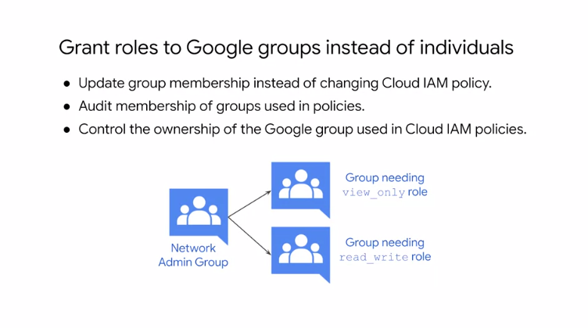

Next, I recommend granting roles to groups instead of individuals. This allows you to update group membership instead of changing a Cloud IAM policy. If you do this, make sure to audit membership of groups used in policies and control the ownership of the Google group used in Cloud IAM policies. You can also use multiple groups to get better control. In the example on this slide, there is a network admin group. Some of those members also need a read write role to a Cloud Storage bucket, but others need the read only role. Adding and removing individuals from all three groups controls their total access. Therefore, groups are not only associated with job roles but can exist for the purpose of role assignment.

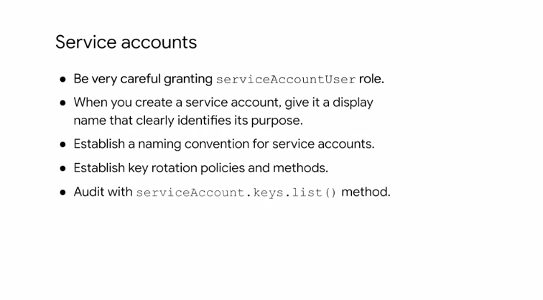

Here are some best practices for using service accounts. As mentioned before, be very careful when granting the service accounts user role because it provides access to all the resources of the service account has access to. Also when you create a service account give it a display name that clearly identifies its purpose, ideally using an established naming convention. As for keys, establish key rotation policies and methods and audit keys with the serviceAccount.keys.list method.

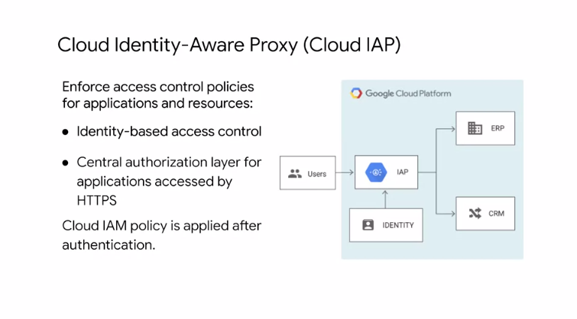

Finally, I recommend using Cloud Identity Aware Proxy or Cloud IAP. Cloud IAP lets you establish a central authorization layer for applications accessed by HTTPS. So you can use an application level access control model instead of relying on network level firewalls. Applications and resources protected by Cloud IAP can only be accessed through the proxy by users and groups with the correct Cloud IAM role. When you grant a user access to an application or resource by Cloud IAP, they're subject to the fine-grained access controls implemented by the product in use without requiring a VPN. Cloud IAP performs authentication and authorization checks when a user tries to access a Cloud IAP secure resource as shown on the right. For more information about Cloud IAP, see the link section of this video.

**Cloud Stage**

Cloud Storage is GCPs objects Storage Service, and it allows worldwide storage and retrieval of any amount of data at anytime. You can use Cloud Storage for a range of scenarios including serving website content storing data for archival and disaster recovery, or distributing large data objects to users via a direct download. Cloud Storage has a couple of key features. It's scalable to exabytes of data. The time to first byte is in milliseconds. It has very high availability across all storage classes, and it has a single API across those storage classes. Some like to think of Cloud Storage as files in a file system, but it's not really a file system. Instead, Cloud Storage is a collection of buckets that you place objects into. You can create directories so to speak, but really a directory is just another object that points to different objects in the bucket. You're not going to easily be able to index all of these files like you would in a file system, you just have a specific URL to access objects.

Cloud Storage has four Storage Classes: regional, multi-regional, nearline, and coldline.

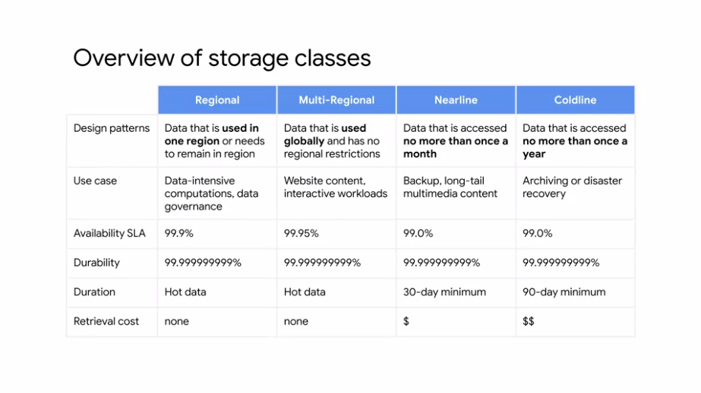

**Regional Storage** enables you to store data at lower cost with the trade-off of data being stored in a specific regional location instead of having redundancy distributed over a large geographic area. I recommend using regional storage when storing frequently accessed data in the same region as your compute engine instances. This provides you with better performance for data intensive computations. You should also choose regional storage for data governance reasons. Like if you're data needs to remain in a specific region.

**Multi-regional storage** on the other hand is Geo-redundant, which means Cloud Storage stores your data redundantly in at least two geographic locations separated by at least 100 miles within the multi-regional location of the bucket. Multi-regional storage can be placed only in multi-regional locations such as the United States, the European Union, or Asia. Multi-regional storage is appropriate for storing data that is frequently accessed such as serving website content, interactive workloads, or data supporting mobile and gaming applications.

**Nearline** storage is a low cost highly durable storage service for storing infrequently accessed data. This storage class is a good choice when you plan to read or modify your data less than once a month because the storage cost is low, but there is an associated retrieval cost. For example, if you want to continuously add files to Cloud Storage and plan to access those files once a month for analysis, nearline storage is a great choice. I also recommend using nearline storage for backups and serving long tail multimedia content.

**Coldline** storage is a very low cost, highly durable storage service for data archival, online backup, and disaster recovery. However, unlike other cold storage services, your data is available within milliseconds not hours or days. Coldline storage is the best choice for data that you plan to access at most once a year due to its lower storage costs but higher retrieval cost. You might use coldline storage if you want to archive data or have access in the event of a disaster recovery event. Let's focus on durability and availability.

All of these storage classes have 11-9's of durability. But what does that mean? Does that mean you have access to your files t all times? No. What that means is that you won't lose data. You may not be able to access the data, which is like going to your bank and saying my money is in there, it's 11-9 durable. But when the bank is closed, I don't have access to it, which is the availability that differs between the storage classes.

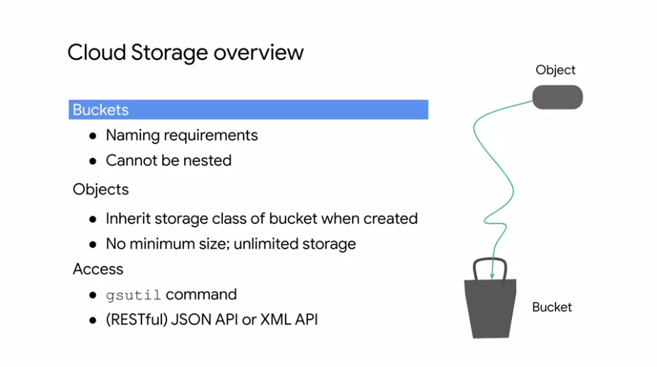

Cloud Storage is broken down into a couple of different items here. First of all, there are buckets which are required to have a globally unique name and cannot be nested. The data that you put into these buckets are objects that inherit the storage class of the bucket, and those objects could be text files, doc files, video files, etc. There is no minimum size to those objects, and you can scale this as much as you want as long as your quota allows it. To access the data, you can use the gsutil command or either the JSON or XML APIs. When you upload an object to the bucket, if you don't specify a storage class for the object, the object is assigned the bucket storage class.

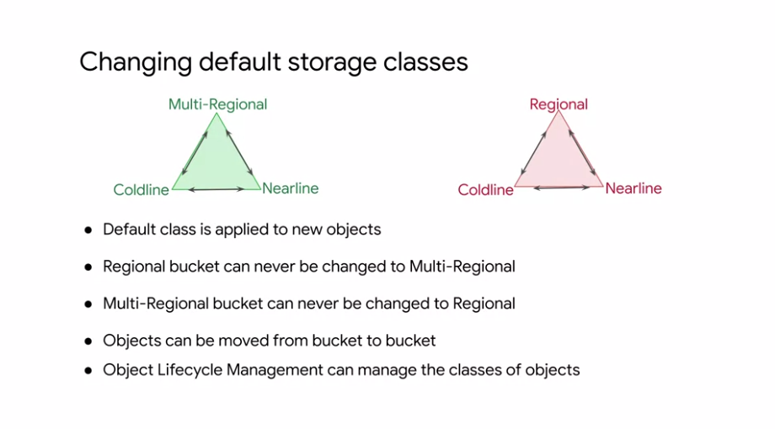

You can change the default storage class of a bucket, but you can't change a regional bucket to a multi-regional and vice versa. As this slide illustrates, both multi-regional buckets and regional buckets can be changed to coldline or nearline. When you upload an object, you can specify a storage class for it. You can also change the storage class of an object that already exists in your bucket without moving the object to a different bucket or changing the URL to the object. Setting a per object storage class is useful. For example, if you have objects in your bucket that you want to keep, but that you don't expect to access frequently. In this case, you can minimize costs by changing the storage class of those specified objects to nearline storage or coldline storage. In order to help manage the classes of objects in your bucket, Cloud Storage offers object life cycle management. More on that later.

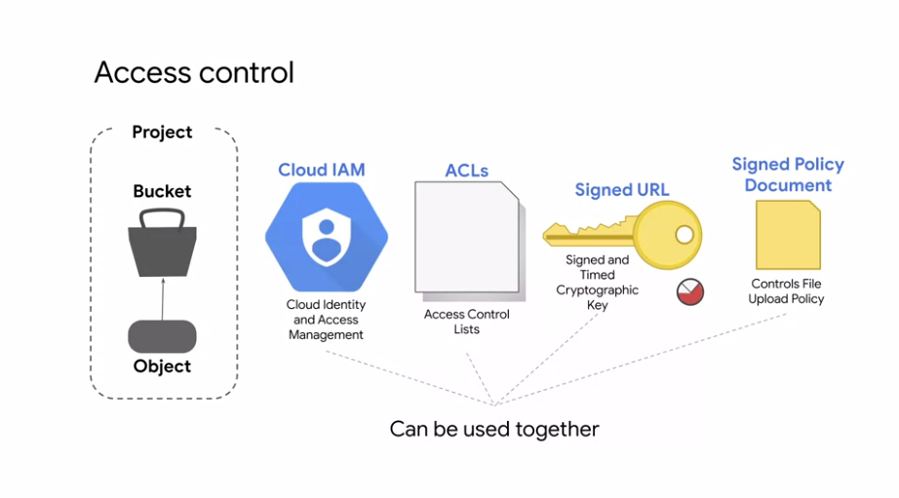

Let's look at access control for your objects and buckets that are part of a project. We can use IAM for the project to control which individual user or service account and can see the bucket, list the objects in the bucket, view the names of the objects in the bucket, or create new buckets.

* For most purposes, Cloud IAM is sufficient. Enrolls are inherited from project to bucket to object.
* Access control list or ACLs offer finer control.
* For even more detailed control, signed URLs provide a cryptographic key that gives time-limited access to a bucket or object.
* Finally, assigned policy document further defines the control by determining what kind of file can be uploaded by someone with assigned URL.

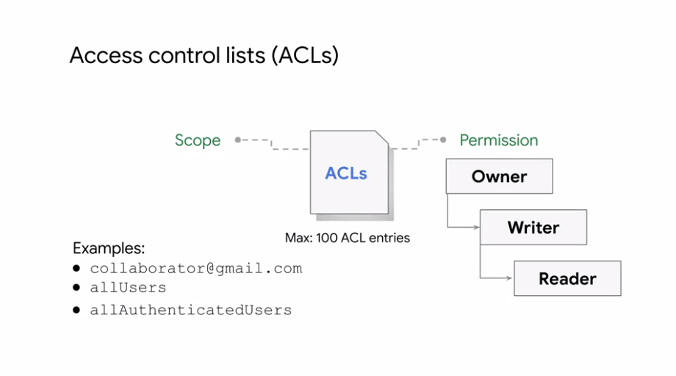

Let's take a closer look at ACLs and signed URLs. An ACL is a mechanism you can use to define who has access to your buckets and objects as well as what level of access they have. The maximum number of ACL entries you can create for a bucket or object is a 100. Each ACL will consists of one or more entries, and these entries consists of two pieces of information. A scope which defines who can perform the specified actions, for example, a specific user or group of users, and a permission, which defines what actions can be performed, for example, read or write. The all users identifier listed on this slide represents anyone who was on the Internet, with or without a Google account. The all authenticated users identifier in contrast represents anyone who is authenticated with a Google account. For more information on ACLs, refer to the links section of this video. For some applications, it is easier and more efficient to grant limited time access tokens that can be used by any user instead of using account-based authentication for controlling resource access, for example, when you don't want to require users to have Google accounts.

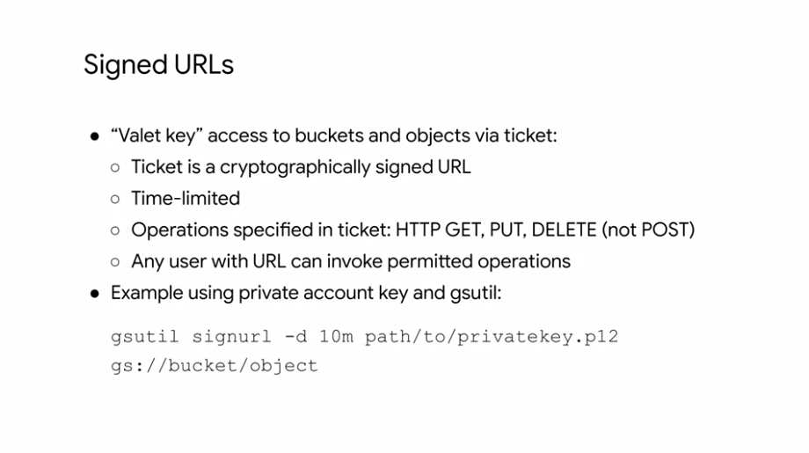

Signed URLs allow you to do this for Cloud Storage. You create a URL, the grants reader right access to a specific Cloud storage resource, and specifies when the access expires. That URL is signed using a private key associated with the service account. When the request is received, Cloud Storage can verify that the access granting URL was issued on behalf of a trusted security principle. In this case, the service account and delegates it's trust of that account to the holder of the URL. After you give out the signed URL, it is out of your control. So you want the signed URL to expire after some reasonable amount of time as shown in this example.

**Cloud Storage Features**

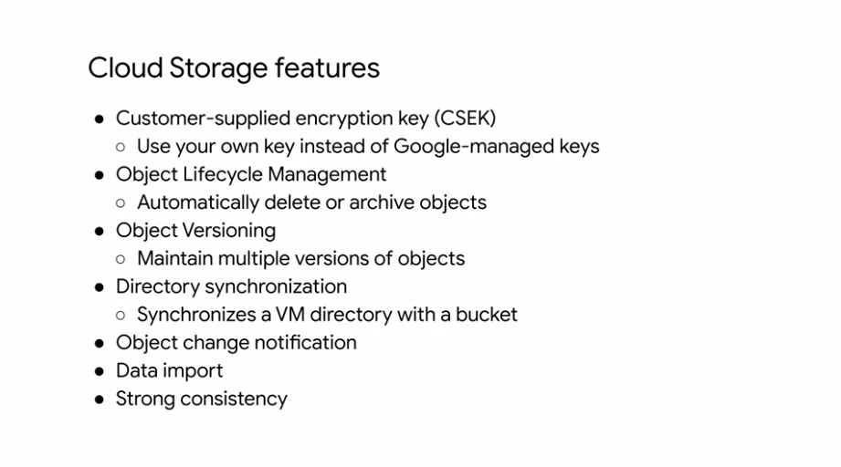

There are also several features that come with Cloud storage, and we'll cover these at a high level for now because we will soon dive deeper into some of them. Earlier in the course series, we already talked a little bit about customer-supplied encryption keys when attaching persistent disks to Virtual Machines. This allows you to supply your own encryption keys instead of the Google-managed keys which is also available for Cloud Storage. Cloud Storage also provides Object Lifecycle Management, which lets you automatically delete or archive objects. Another feature is object versioning, which allows you to maintain multiple versions of objects in your buckets. You are charged for the versions as if they were multiple files, which is something to keep in mind. Cloud Storage also offers directory synchronization so that you can sink a VM directory with a bucket. We will discuss object change notification, data import, and strong consistency in more detail after going into object versioning and Object Lifecycle Management. In Cloud Storage, objects are immutable, which means that an uploaded object cannot change through its storage lifetime.

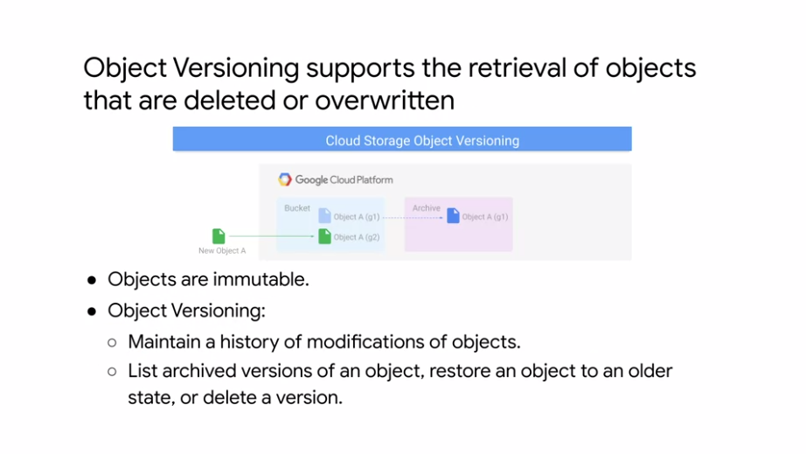

To support the retrieval of objects that are deleted or overwritten, Cloud Storage offers the object versioning feature. Object versioning can be enabled for a bucket. Once enabled, Cloud Storage creates an archived version of an object each time the live version of the object is overwritten or deleted. The archived version retains the name of the object, but is uniquely identified by a generation number as illustrated on this slide by g1. When object versioning is enabled, you can list archived versions of an object, restore the live version of an object to an older state, or permanently delete an archived version as needed. You can turn versioning on or off for a bucket at anytime. Turning versioning off leaves existing object versions in place, and causes the bucket to stop accumulating new archived object versions. For more information on object versioning, refer to the links section of this video.

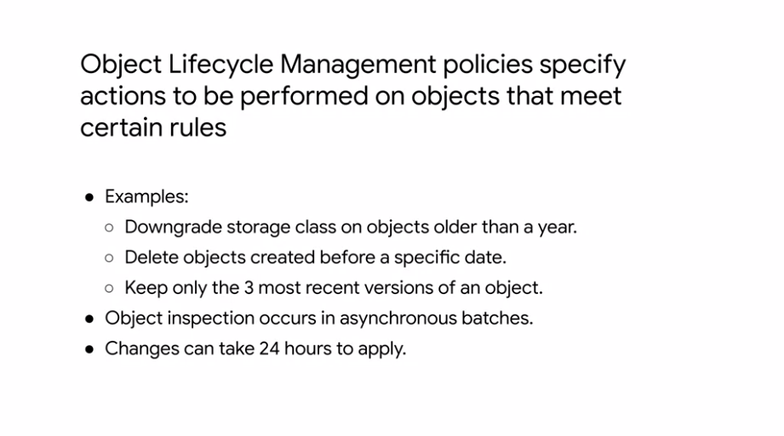

To support common use cases like setting a time to live for objects, archiving older versions of objects, or downgrading storage classes of objects to help manage costs, Cloud Storage offers Object Lifecycle Management. You can assign a lifecycle management configuration to a bucket. The configuration is a set of rules that apply to all of the objects in the bucket. So when an object meets the criteria of one of the rules, Cloud Storage automatically performs a specified action on the object. Here are some example use cases. Downgrade the storage class of objects older than a year to coldline storage. Delete objects created before a specific date. For example, January 1st, 2017. Keep only the three most recent versions of each object in a bucket with versioning enabled. Object inspection occurs in asynchronous batches. So rules may not be applied immediately. Also updates to your lifecycle configuration may take up to 24 hours to go into effect. This means that when you change your lifecycle configuration, object lifecycle management may still perform actions based on the old configuration for up to 24 hours. So keep that in mind. For more information on Object Lifecycle Management, refer to the links section of this video.

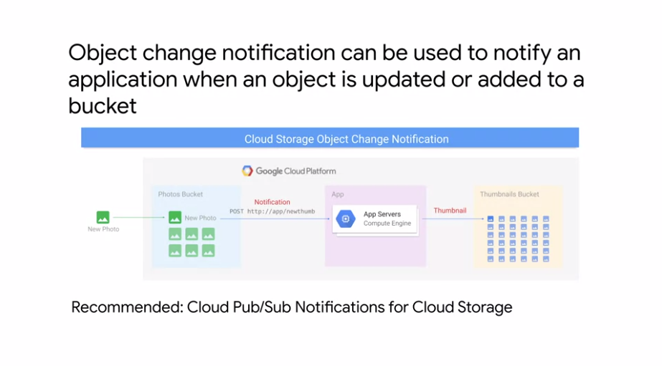

Object change notification can be used to notify an application when an object is updated or added to a bucket through a watch request. Completing a watch request creates a new notification channel. The notification channel is the means by which a notification message is sent to an application watching a bucket. As of this recording, the only type of notification channels supported is a WebHook. After a notification channel is initiated, Cloud Storage notifies the application anytime an object is added, updated, or removed from the bucket. For example as shown here, when you add a new picture to a bucket, an application can be notified to create a thumbnail. However, Cloud Pub/Sub notifications are the recommended way to track changes to objects in your Cloud Storage buckets because they're faster, more flexible, easier to set up, and more cost-effective. Cloud Pub/Sub is Google's distributed real-time messaging service, which is covered in the developing applications track.

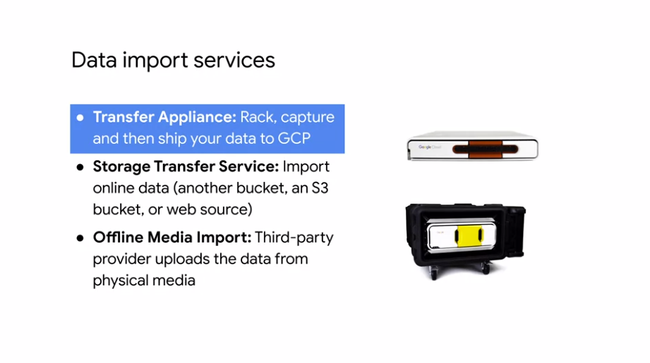

The GCP console allows you to upload individual files to your bucket. What if you have to upload terabytes or even petabytes of data? There are three services that address this. Transfer Appliance, Storage Transfer Service, and Offline Media Import. Transfer appliance is a hardware appliance you can use to securely migrate large volumes of data from hundreds of terabytes up to one petabyte to GCP without disrupting business operations. The images on this slide are transfer appliances. The Storage transfer service enables high-performance imports of online data. That data source can be another Cloud Storage bucket in Amazon S3 bucket or an HTTP, HTTPS location. Finally, offline media import is a third-party service where physical media such as storage arrays, hard-disk drives, tapes, and USB flash drives is sent to a provider who uploads the data. For more information on these three services, refer to the links section of this video.

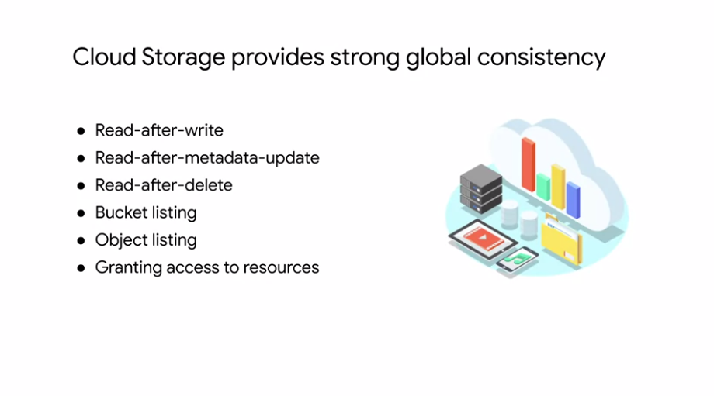

When you upload an object to Cloud Storage and you receive a successor response, the object is immediately available for download and metadata operations from any location where Google offers service. This is true whether you create a new object or overwrite an existing object. Because uploads are strongly consistent, you will never receive a 404 Not Found response or stale data for a read after write or read after metadata update operation. Strong global consistency also extends to deletion operations on objects. If a deletion requests succeeds, an immediate attempt to download the object or its metadata will result in a 404 Not Found status code. You get the 404 error because the object no longer exists after the delete operation succeeds. Bucket listing is strongly consistent. For example, if you create a bucket then immediately perform a list buckets operation, the new bucket appears in the returned list of buckets. Finally, object listing is also strongly consistent. For example, if you upload an object to a bucket and then immediately perform a list objects operation, the new object appears in the returned list of objects.

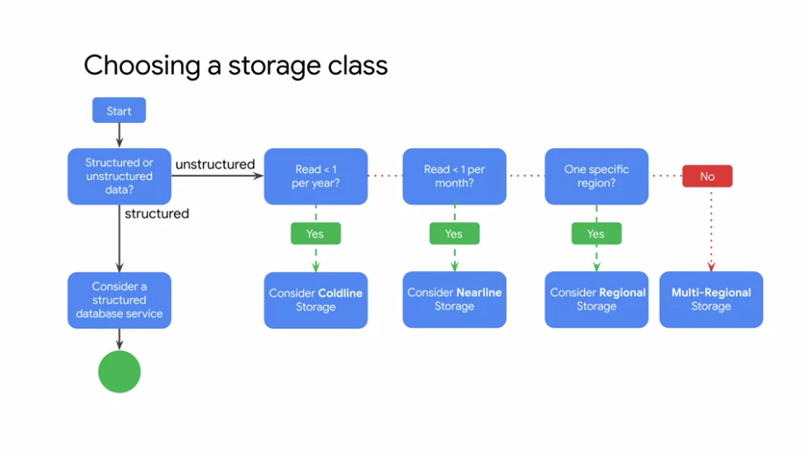

Let's explore the decision tree to help you find the appropriate storage class in Cloud Storage.. If you will read your data less than once a year, you should consider using coldline storage. If you will read your data less than once a month, you should consider using Nearline storage, and if you'll be doing reads and writes more often than that, you should consider choosing multi-regional or regional depending on your locality needs. So far, we have only considered unstructured data. Structured data services are covered next.

**Cloud SQL**

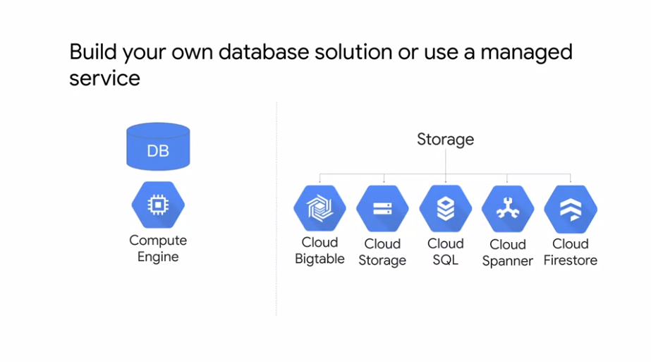

Let's dive into the structured or relational database services. First step is Cloud SQL. Why would you use a GCP service for SQL, when you can install a SQL Server application image on a VM using Compute Engine? The question really is, should you build your own database solution or use a managed service? There are benefits to using a managed service. So let's learn about why you'd use Cloud SQL as a managed service inside of GCP.

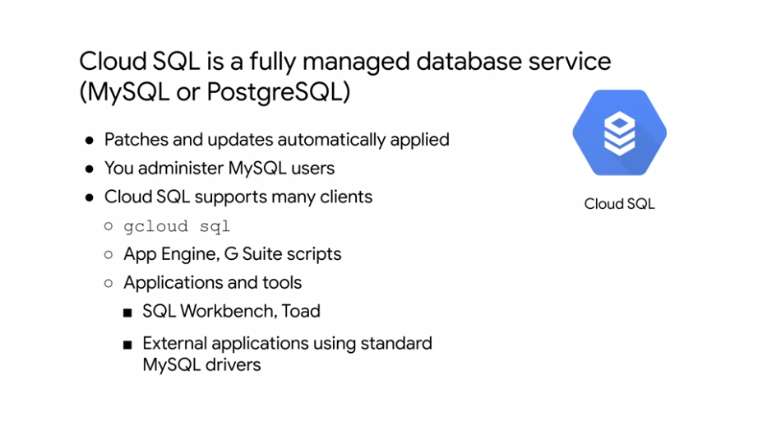

Cloud SQL is a fully managed service of either MySQL or PostgreSQL databases. This means that patches and updates are automatically applied, but you still have to administer MySQL users with the native authentication tools that come with these databases. Cloud SQL supports many clients such as Cloud Shell, App Engine, and G-Suite scripts. It also supports other applications and tools that you might be used to using like SQL Workbench, Toad, and other external applications using standard MySQL drivers.

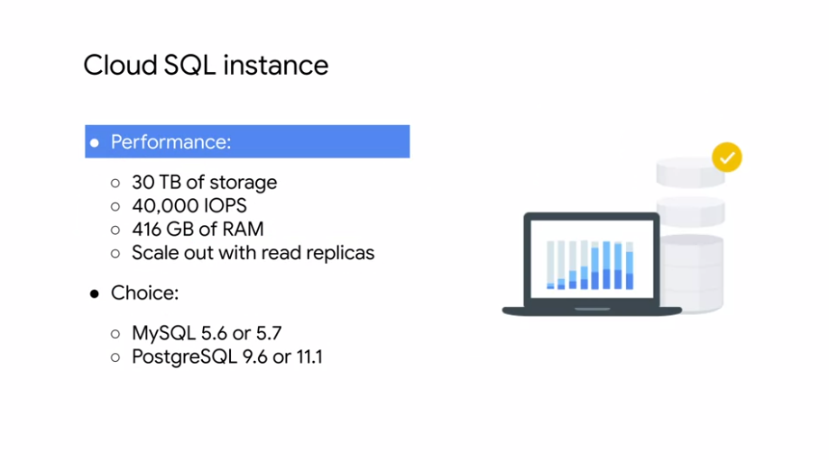

Cloud SQL delivers high performance and scalability with up to 30 terabytes of storage capacity, 40,000 IOPS, and 416 gigabytes of RAM per instance. You can easily scale up to 64 processor cores, and scale out with read replicas. You can use Cloud SQL with either MySQL 5.6 or 5.7, or PostgreSQL 9.6 or 11.1 as of this recording. Let's focus on some other services provided by Cloud SQL.

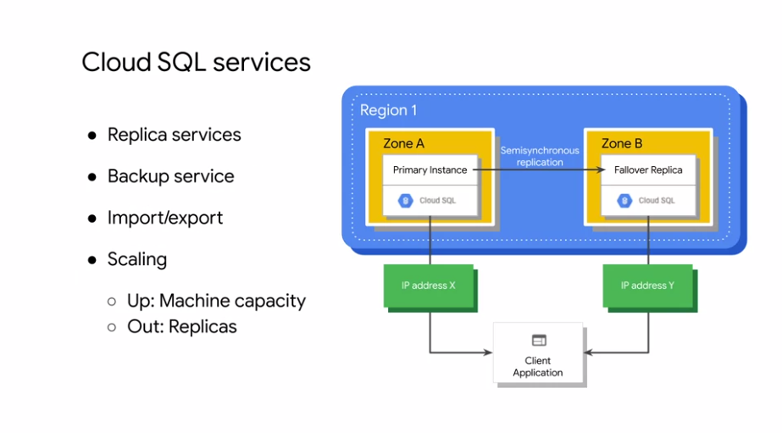

There is a replica service that can replicate data between multiple zones as shown on the right. This is useful for automatic failover if an outage occurs. Cloud SQL also provides automated and on-demand backups with point-in-time recovery. You can import and export databases using MySQL dump, or import and export CSV files. Cloud SQL can also scale up which does require a machine restart or scale out using read replicas. That being said, if you are concerned about horizontal scalability, you'll want to consider Cloud Spanner which we'll cover later in this module.

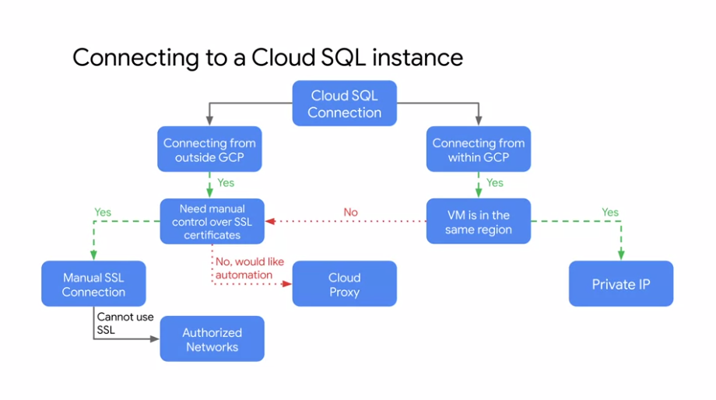

Choosing a connection type to your Cloud SQL instance, will influence how secure, performance, and automated it will be.

* If you are connecting an application that is hosted within the same GCP project as your Cloud SQL instance, and it is co-located in the same region, choosing the private IP connection will provide you with the most performance and secure connection using private connectivity. In other words, traffic is never exposed to the public Internet.
* If the application is hosted in another region or project, or if you are trying to connect to your Cloud SQL instance from outside of GCP, you have three options.
  + In this case, I recommend using Cloud Proxy which handles authentication, encryption, and key rotation for you.
  + If you need manual control over the SSL connection, you can generate and periodically rotate the certificates yourself. Otherwise, you can use an unencrypted connection by authorizing a specific IP address, to connect to your SQL server, over its external IP address.

You will explore these options in the upcoming lab. But if you want to learn more about private IP, see the link section of this video.

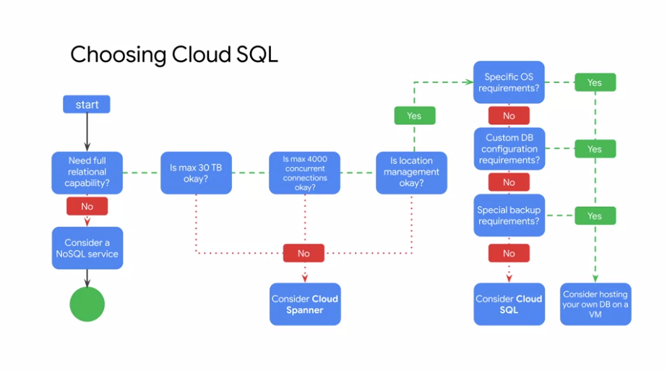

To summarize, let's explore this decision tree to help you find the right data storage service with full relational capability.

* If you need more than 30 terabytes of storage space, or over 4,000 concurrent connections to your database, or if you want your application designed to be responsible for scaling, availability, and location management when scaling up globally, then consider using Cloud Spanner which we will cover later in this module.
* If you have no concerns with these constraints, ask yourself whether you have specific OS requirements, custom database configuration requirements, or special backup requirements.
* If you do, consider hosting your own database on a VM using Compute Engine.
* Otherwise, I strongly recommend using Cloud SQL as a fully managed service for your relational databases. If you're now convinced that using Cloud SQL as a managed service is better than using or re-implementing your existing MySQL solution, see the link section for a solution on how to migrate from MySQL to Cloud SQL.

**Cloud Spanner**

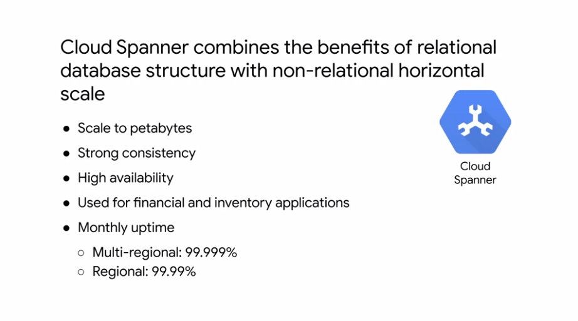

If Cloud SQL does not fit your requirements because you need horizontal scalability, consider using Cloud Spanner. Cloud Spanner is a service built for the Cloud, specifically to combine the benefits of relational database structure with non-relational horizontal scale. This service can provide petabytes of capacity and offers transactional consistency at global scale, schemas, SQL, and automatic synchronous replication for high availability. Use cases include financial applications and inventory applications, traditionally served by relational database technology. Depending on whether you create a multi-regional or regional instance, you'll have different monthly up-time SLAs as shown on this slide. However, for up-to-date numbers, you should always refer to the documentation which you'll find in the link section of this video. Let's compare Cloud Spanner with both relational and non-relational databases. Like a relational database, Cloud Spanner has schema, SQL, and strong consistency.

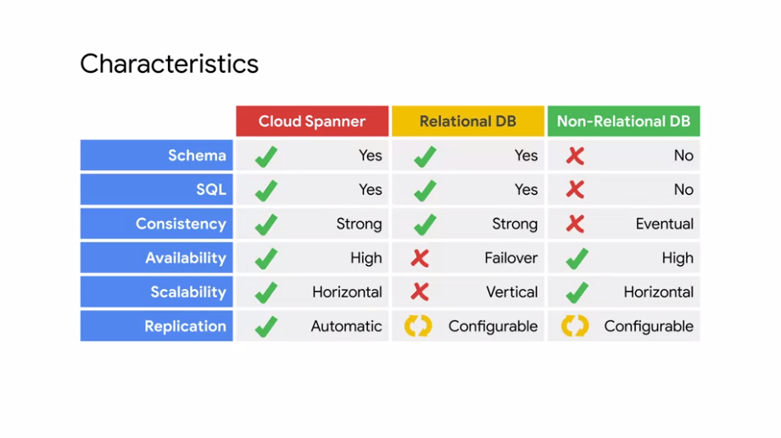

Also like a non-relational database, Cloud Spanner offers high availability, horizontal scalability, and configurable replication. As mentioned, Cloud Spanner offers the best of the relational and non-relational worlds. These features allow for mission-critical use cases such as building consistent systems for transactions and inventory management in the financial services in retail industries. To better understand how all of it works, let's look at the architecture of Cloud Spanner. Cloud Spanner instance replicates data in n Cloud zones, which can be within one region or across several regions. The database placement is configurable. Meaning, you can choose which region to put your database in.

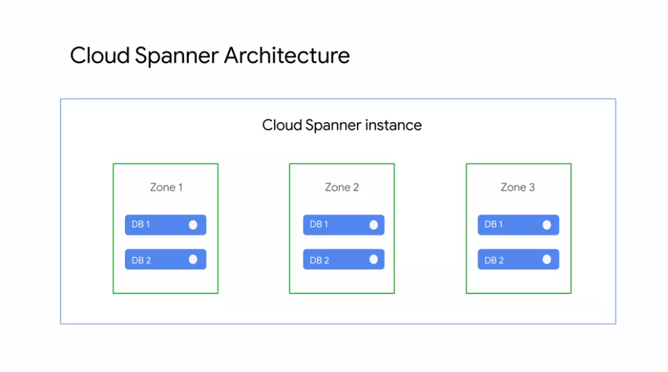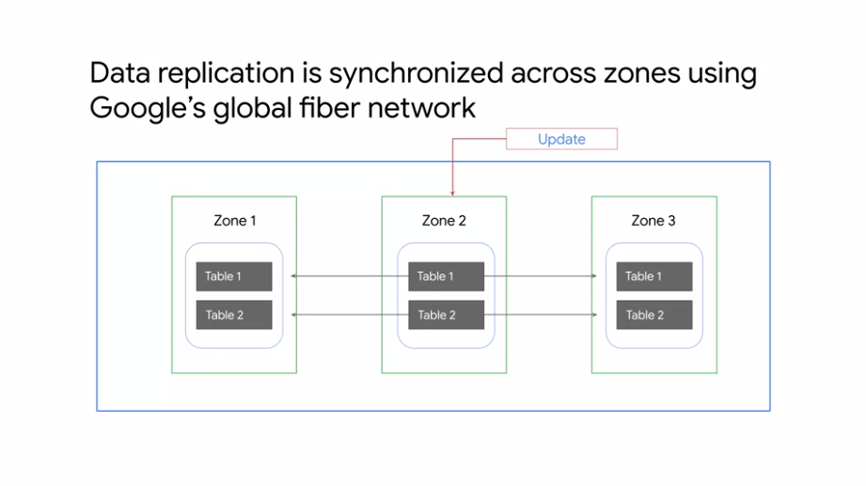

This architecture allows for high availability and global placement. The replication of data, will be synchronized across zones using Google's global fiber network. Using atomic clocks, ensures atomicity whenever you are updating your data. That's as far as we're going to go with Cloud Spanner. Because the focus of this module, is to understand the circumstances when you would use Cloud Spanner.

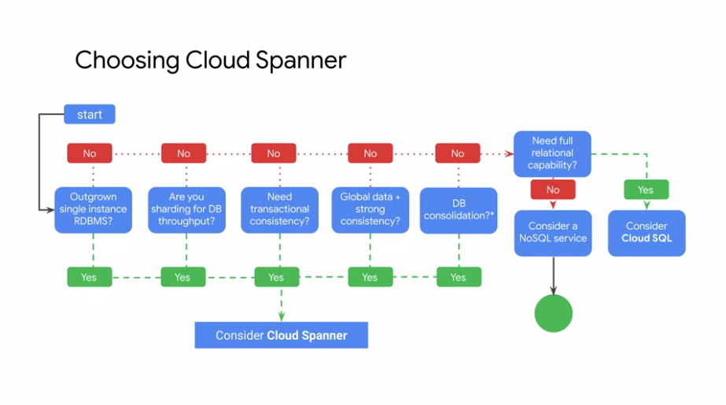

Let's look at a decision tree.

* If you have outgrown any relational database or sharding your databases for throughput high-performance, need transactional consistency, global data, and strong consistency, or just want to consolidate your database. Consider using Cloud Spanner.
* If you don't need any of these nor full relational capabilities, consider a NoSQL service such as Cloud fire store which we will cover next.

If you're now convinced that using Cloud Spanner as a managed service is better than using or re-implementing your existing MySQL solution, see the link section for a solution on how to migrate from MySQL to Cloud Spanner.

**Cloud Firestore**

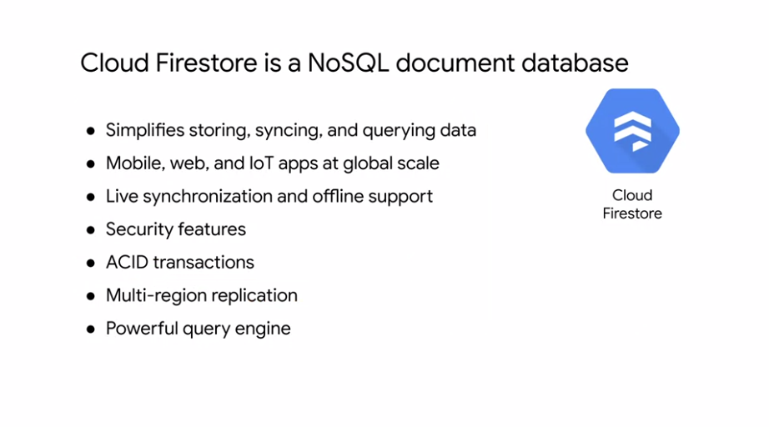

If you are looking for a highly scalable NoSQL database for your applications, consider using Cloud Firestore. Cloud Firestore is a fast, fully managed, serverless Cloud native, NoSQL document database, that simplifies storing, sinking, and querying data for your mobile, web, and IoT apps at global scale. It's client libraries provide live synchronization and offline support, and it's security features and integrations with Firebase and GCP accelerate building truly serverless apps. Cloud Firestore also supports ACID transactions. So if any of the operations in the transaction fail and cannot be retried, the whole transaction will fail. Also with automatic multi-region replication and strong consistency, your data is safe and available even when disasters strike. Cloud Firestore also supports ACID transactions. So if any of the operations in the transaction fail and cannot be retried, the whole transaction will fail. Also with automatic multi-region replication and strong consistency, your data is safe and available even when disasters strike. Cloud Firestore even allows you to run sophisticated queries against your NoSQL data, without any degradation in performance, this gives you more flexibility in the way you structure your data.

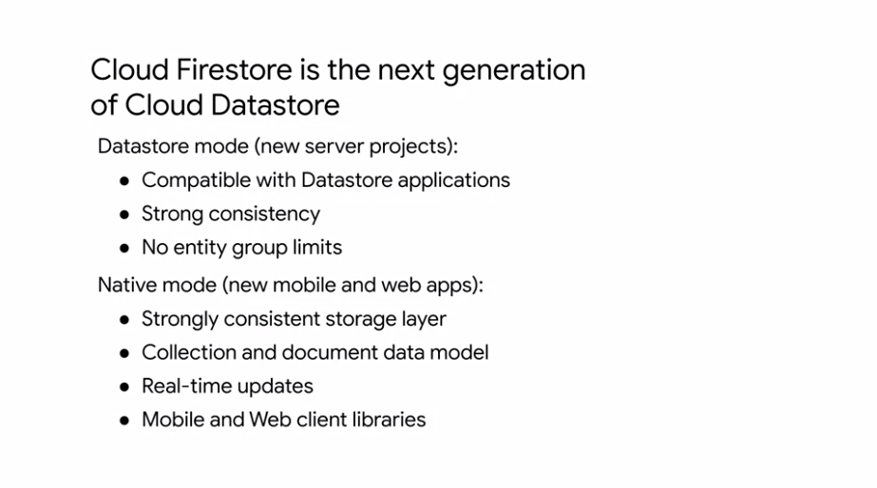

Cloud Firestore is actually the next generation of Cloud Datastore. Cloud Firestore can operate in Datastore mode, making it backwards compatible with Cloud Datastore. By creating a Cloud Firestore database in Datastore mode, you can access Cloud Firestore improved storage layer, while keeping Cloud Datastore system behavior. This removes the following Cloud Datastore limitations. Queries are no longer eventually consistent. Instead they are all strongly consistent. Transactions are no longer limited to 25 entity groups, rights to an entity group are no longer limited to one per second. Cloud Firestore in native mode, introduces new features such as a new strongly consistent storage layer. A collection and document data model, real-time updates, mobile and web client libraries. Cloud Firestore is backward compatible with Cloud Datastore, but the new data mode, real-time updates in mobile and web client library features are not. To access all of the new Cloud Firestore features, you must use Cloud Firestore in native mode. A general guideline is to use Cloud Firestore in Datastore mode for new server projects and native mode for new mobile and web apps. As the next generation of Cloud Datastore, Cloud Firestore is compatible with all Cloud Datastore APIs and client libraries. Existing Cloud Datastore users will be live upgraded to Cloud Firestore automatically at a future date, for more information see the link section of this video.

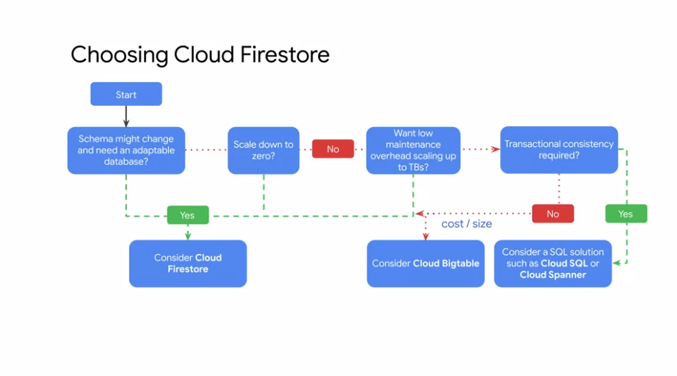

To summarize, let's explore this decision tree, to help you determine whether Cloud Firestore is the right storage service for your data. If your schema might change and you need an adaptable database, you need to scale to zero or you want low maintenance overhead scaling up to terabytes, consider using Cloud Firestore. Also, if you don't require transactional consistency, you might want to consider Cloud Bigtable, depending on the cost or size. I will cover Cloud Bigtable next.

Cloud Bigtable

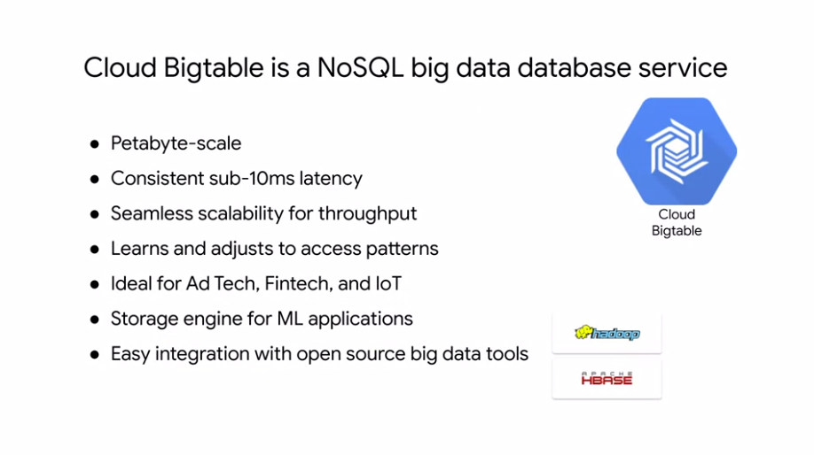

If you don't require transactional consistency, you might want to consider Cloud Bigtable. Cloud Bigtable is a fully managed NoSQL database with petabyte-scale and very low latency. It seamlessly scales for throughput, and it learns to adjust to specific access patterns. Cloud Bigtable is actually the same database that powers many of Google's core services including Search, Analytics, Maps, and Gmail. Cloud Bigtable is a great choice for both operational and analytical applications including IoT, user analytics, and financial data analysis because it supports high read and write throughput at low latency. It's also a great storage engine for machine learning applications. Cloud Bigtable integrates easily with popular big data tools like Hadoop, Cloud Dataflow, and Cloud Dataproc, plus Cloud Bigtable supports the open-source industry standard HBase API, which makes it easy for your development teams to get started. Cloud Dataflow and Cloud Dataproc are covered later in the course series. For more information on the HBase API, see the link section of this video.

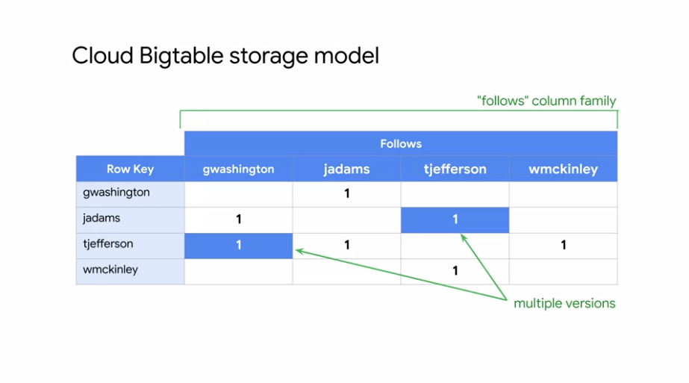

Cloud Bigtable stores data in massively scalable tables, each of which is a sorted key value map. The table is composed of rows, each of which typically describes a single entity, and columns which contain individual values for each row. Each row is indexed by a single row key. Columns that are related to one another are typically grouped together into a column family. Each column is identified by a combination of the column family and a column qualifier which is a unique name within the column family. Each row column intersection can contain multiple cells or versions at different timestamps, providing a record of how the stored data has been altered over time. Cloud Bigtable tables are sparse. If a cell does not contain any data, it does not take up any space. The example shown here is for a hypothetical social network for United States presidents, where each president can follow posts from other presidents. Let me highlight some things. The table contains one column family, the follows family. This family contains multiple column qualifiers. Column qualifiers are used as data. This design choice takes advantage of the sparseness of Cloud Bigtable tables and the fact that new column qualifiers can be added as your data changes. The username is used as the row key. Assuming usernames are evenly spread across the alphabet, data access will be reasonably uniform across the entire table. This diagram shows a simplified version of Cloud Bigtables overall architecture. It illustrates that processing which is done through a front end server pool and nodes is handled separately from the storage.

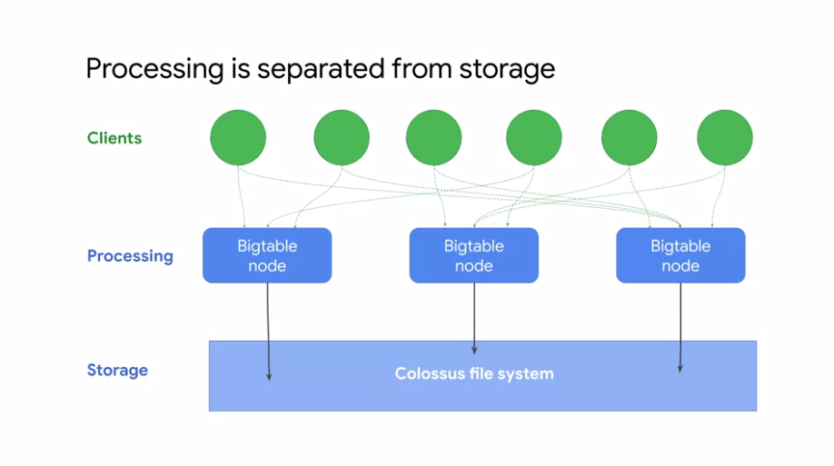

A Cloud Bigtable table is sharded into blocks of contiguous rows called tablets, to help balance the workload of queries. Tablets are similar to HBase regions, for those of you who might have used the HBase API. Tablets are stored on Colossus which is Google's file system in SSTable format. An SSTable provides a persistent, ordered, immutable map from keys to values where both keys and values are arbitrary byte strings. As I mentioned earlier, Cloud Bigtable learns to adjust to specific access patterns. If a certain Bigtable node is frequently accessing a certain subset of data, Cloud Bigtable will update the indexes so that other nodes can distribute that workload evenly as shown here. That throughput scales linearly, so for every single node that you do add, you're going to see a linear scale of throughput performance up to hundreds of nodes.

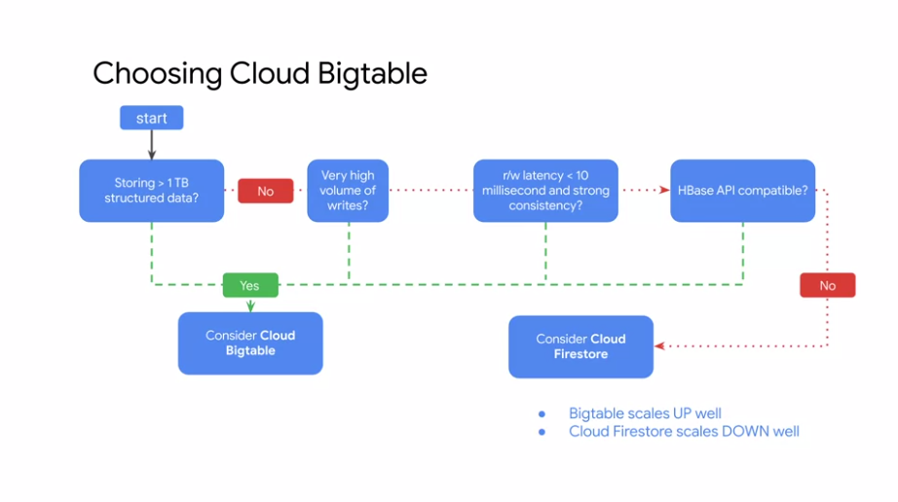

In summary, if you need to store more than one terabyte of structured data, have very high volumes of writes. Need read write latency of less than 10 milliseconds along with strong consistency or need a storage service that is compatible with the HBase API. Consider using Cloud Bigtable. If you don't need any of these and are looking for a storage service that scales down well, consider using Cloud Firestore. Speaking of Scaling, the smallest Cloud Bigtable cluster you can create has three nodes and can handle 30,000 operations per second. Remember that you pay for those nodes while they are operational, whether your application is using them or not.

**Cloud Memorystore**

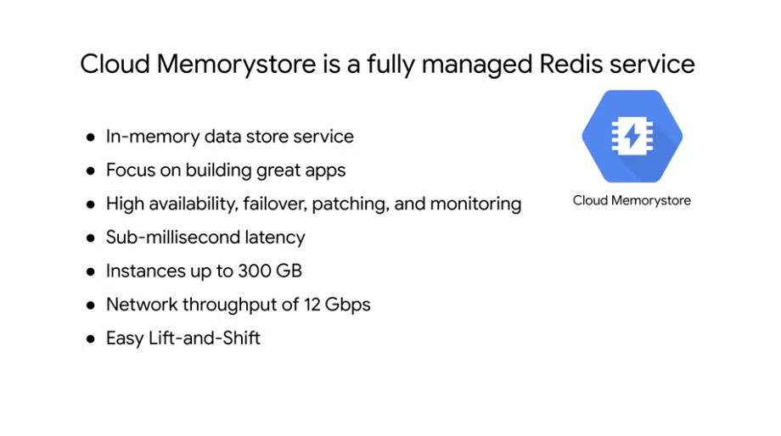

Let me give you a quick overview of Cloud Memorystore. Cloud Memorystore for Redis provides a fully managed in-memory data store service built on scalable, secure, and highly available infrastructure managed by Google. Applications running on GCP can achieve extreme performance by leveraging the highly scalable available secure Redis service without the burden of managing complex reddest deployments. This allows you to spend more time writing code, so that you can focus on building great apps. Cloud Memorystore also automates complex tasks like enabling high availability, failover, patching, and monitoring. High availability instances are replicated across two zones and provide a 99.9 percent availability SLA. You can easily achieve this sub-millisecond latency and throughput your applications need. Start with the lowest tier and smallest size and then grow your instance effortlessly with minimal impact to application availability. Cloud Memorystore can support instances of up to 300 gigabytes and network throughput of 12 gigabytes per second. Because Cloud Memorystore for Redis is fully compatible with the Redis protocol, you can lift-and-shift your applications from open-source Redis to Cloud Memorystore without any code changes by using the import export feature. There is no need to learn new tools because all existing tools in Client Libraries just work.

**Cloud Resource Manager**

The resource manager lets you hierarchically manage resources by project, folder, and organization. This should sound familiar because we covered it in the Cloud IAM module. Let me refresh your memory. Policies contain a set of roles and members, and policies are set on resources. These resources inherit policies from their parent as we can see on the left. Therefore, resource policies are a union of parent and resource. Also, keep in mind that if a parent policy is less restrictive, it overrides the more restrictive resource policy. Although IAM policies are inherited top to bottom, billing is accumulated from the bottom up, as we can see on the right. Resource consumption is measured in quantities like rate of use or time, number of items, or feature use. Because a resource belongs to only one project, a project accumulates the consumption of all its resources. Each project is associated with one billing account, which means that an organization contains all billing accounts. Let's explore organizations, projects, and resources more. Just to reiterate, an organization node is the root node for all Google Cloud Platform resources. This diagram shows an example where we have an individual Bob, who has control of the organizational domain through the organization admin role. Bob has delegated privileges and access to the individual projects to Alice by making her a project creator. Because a project accumulates the consumption of all its resources, it can be used to track resources and quota usage. Specifically, projects that you enable billing, manage permissions and credentials, and enabled service and APIs. To interact with Cloud Platform resources, you must provide the identifying project information for every request. A project can be identified by the project name, which is a human-readable way to identify your projects, but it isn't used by any Google APIs. There's also the project number, which is automatically generated by the server and assigned to your project, and there is the Project ID, which is a unique ID that is generated from your project name. You can find these three identifying attributes on the dashboard of your GCP console, or by querying the Resource Manager API. Finally, let's talk about the resource hierarchy. From a physical organization standpoint, resources are categorized as global, regional, or zonal. Let's look at some examples. Images, snapshots, and networks, are global resources. External IP addresses are regional resources, and instances and disks are zonal resources. However, regardless of the type, each resource is organized into a project. This enables each project to have its own billing and reporting.

**Quotas**

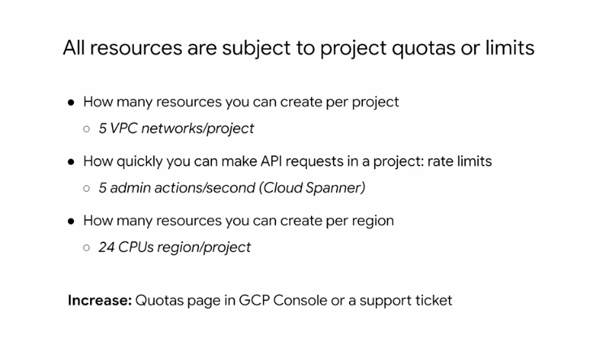

Now that we know that a project accumulates the consumption of all its resources, let's talk about quotas. All resources and GCP are subject to project quotas or limits. These typically fall into one of the three categories shown here. How many resources you can create per project? For example, you can only have five VPC networks for project. How quickly you can make API requests in a project or rate limits. For example, by default, you can only make five administrative actions per second per project when using the Cloud Spanner API. There are also regional quotas. For example, by default, you can only have 24 CPUs per region. Given these quotas, you may be wondering, how do I spin up one of those 96 core VMs? As your use of GCP expands over time, your quotas may increase accordingly. If you expect a notable upcoming increasing usage, you can proactively request quota adjustments from the quotas page in the GCP Console. This page will also display your current quotas. If quotas can be changed, why do they exist?

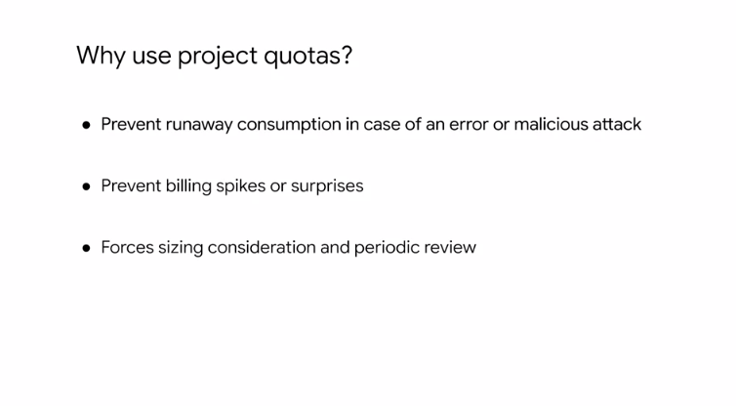

Project quotas prevent runaway consumption in case of an error or malicious attack. For example, imagine you accidentally create a 100 instances instead of 10 Compute Engine instances using the gcloud command-line. Quotas also prevent billing spikes or surprises. Quotas are related to billing, but we will go through how to set up budgets and alerts later, which will really help you manage billing. Finally, quotas forces consideration and periodic review. For example, do you really need a 96 Core instance? Or can you go with a smaller and cheaper alternative? It is also important to mention the quotas are the maximum amount of resources you can create for that resource type as long as those resources are available. Quotas do not guarantee that resources will be available at all times. For example, if a region is out of local SSDs, you cannot create local SSDs in that region even if you still had quota for local SSDs.

**Labels and names**

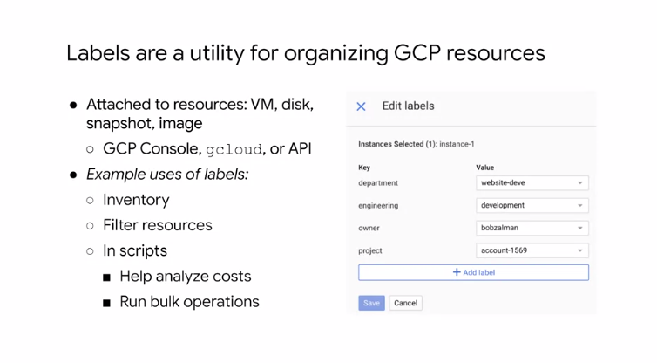

Projects and folders provide levels of segregation for resources. But what if you want more granularity? That's where labels and names come in. Labels are a utility for organizing GCP resources. Labels are key value pairs that you can attach to your resources like VMs, disks, snapshots, and images. You can create and manage labels using the GCP Console, gcloud or the Resource Manager API, and each resource can have up to 64 labels. For example, you could create a label to define the environment of your virtual machines. Then you define the label for each of your instances as either production or test. Using this label, you could search and list all of your production resources for inventory purposes. Labels can also be used in scripts to help analyze costs or to run bulk operations on multiple resources. The screenshot on the right shows an example of four labels that are created on an instance.

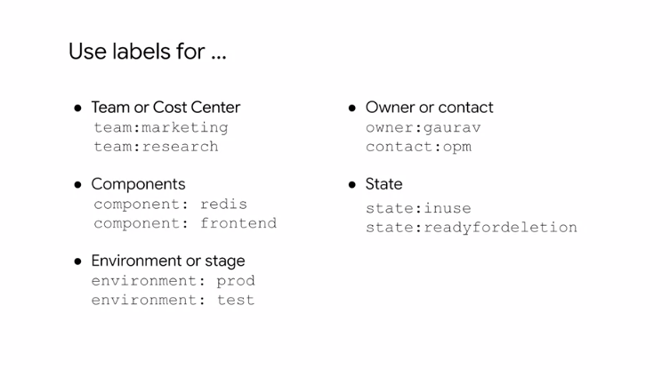

Let's go over some examples of what to use labels for. I recommend adding labels based on team or cost center to distinguish instances owned by different teams. You can use this type of label for cost accounting or budgeting. For example, team colon marketing and team colon research. You can also use labels to distinguish components. For example, component colon redis, component colon front end. Again, you can label based on environment or stage. You should also consider using labels to define an owner or a primary contact for a resource. For example, owner colon gaurav, contact colon OPM or add labels to your resources to define their state. For example, state colon in-use, state colon ready for deletion.

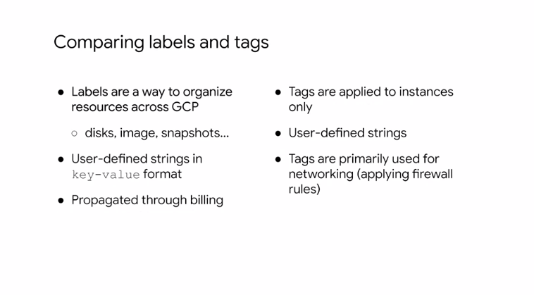

Now it's important to not confuse labels with tags. Labels, we just learned, are user-defined strings in key-value format that are used to organize resources and they can propagate through billing. Tags, on the other hand, are user-defined strings that are applied to instances only and are mainly used for networking such as applying firewall rules. For more information about using labels see the link section of this video.

**Billing**

Because the consumption of all resources under a project accumulates into one billing account, let's talk billing. To help with project planning and controlling costs. You can set a budget. Setting a budget lets you track how your spend is growing towards that amount. This screenshot shows the budget creation interface. First, you set a budget name and specify which project this budget applies to. Then you can set the budget at a specific amount or match it to the previous month spend. After you determine your budget amount, you can set the budget alerts. These alerts send emails to billing admins after spend exceeds a percentage of the budget or a specified amount. In our case, it would send an email when spending reaches 50 percent, 90 percent and a 100 percent of the budget amount. You can even choose to send an alert when the spend is forecasted to exceed the percent of the budget amount by the end of the budget period. In addition to receiving an email, you can use Cloud Pub Sub notifications to programmatically receive spend updates about this budget. You could even create a Cloud Function that listens to the Pub Sub topic to automate cost management. For an example of programmatic budget notifications, see the link section of this video. Here's an example of an email notification. The email contains the project name, the percent of the budget that was exceeded, and the budget amount. Another way to help optimize your GCP spend is to used labels. For example, you could label VM instances that are spread across different regions. Maybe these instances are sending most of their traffic to a different continent which could incur higher cost. In that case, you might consider relocating some of those instances or using a caching service like Cloud CDN to cach content closer to your users, which reduces your networking spend. I recommend labeling all your resources and exporting your billing data to BigQuery to analyze your spend. BigQuery is Google's scalable, bully managed enterprise data warehouse with SQL and fast response times. Creating a query is as simple as shown in this screenshot, which you will explore in the upcoming lab. You can even visualize spend over time with Data studio. Data Studio turns your data into an formative dashboards and reports that are easy to read, easy to share, and fully customizable. For example, you can slice and dice your billing reports using your labels.

**Monitoring**

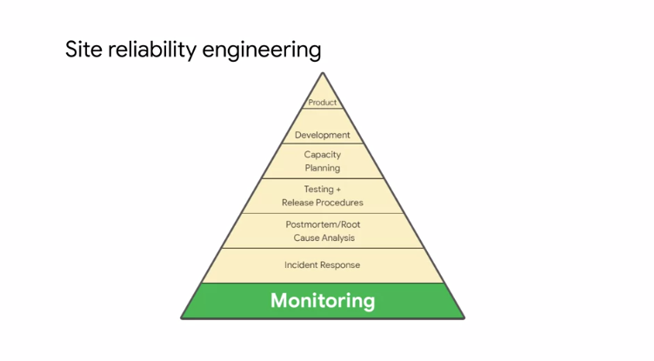

Now that you understand Stackdriver from a high-level perspective, let's look at Stackdriver monitoring. Monitoring is important to Google, because it is at the base of Site Reliability Engineering or SRE. SRE is a discipline that applies aspects of software engineering to operations whose goals are to create ultra scalable and highly reliable software systems. This discipline has enabled Google to build, deploy, monitor, and maintain some of the largest software systems in the world. If you want to learn more about SRE, I recommend exploring the free book written by members of Google's SRE team. It is in the link section of this video.

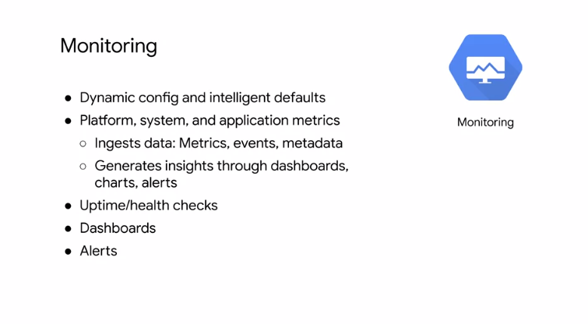

Stackdriver dynamically configures monitoring after resources are deployed, and has intelligent defaults that allow you to easily create charts for basic monitoring activities. This allows you to monitor your platform system and application metrics by ingesting data such as metrics, events, and metadata. You can then generate insights from this data through dashboards, charts, and alerts. For example, you can configure and measure uptime and health checks, it'll send alerts via e-mail.

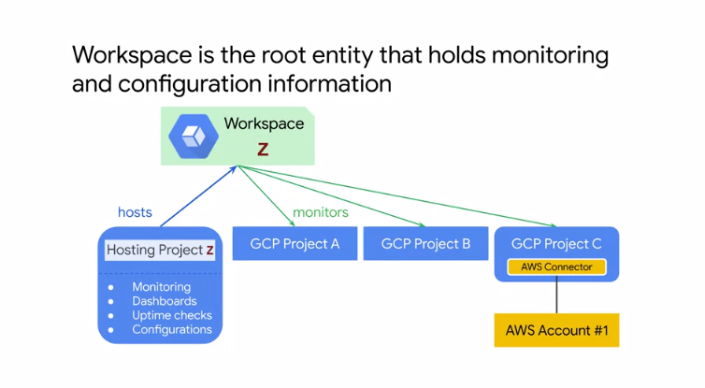

A workspace is the root entity that holds monitoring and configuration information in Stackdriver monitoring. Each workspace can have between 100 monitored projects including one or more GCP projects and any number of AWS accounts. You can have as many workspaces as you want, but GCP projects and AWS accounts can be monitored by more than one workspace. A workspace contains the custom dashboards, alerting policies, uptime checks, notification channels, and group definitions that you use with your monitored projects. A workspace can access metric data from its monitored projects. But the metric data and log entries remain in the individual projects. The first monitor GCP project in a workspace is called the hosting project. It must be specified when you create the workspace. The name of that project becomes a name of your workspace. To access an AWS account, you must configure a project in GCP to hold the AWS connector.

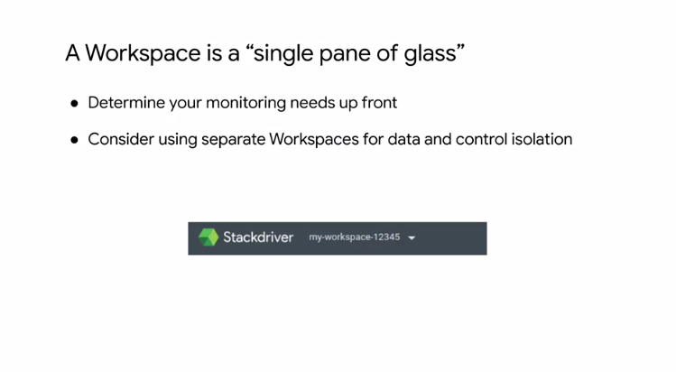

Because workspaces can monitor all of your GCP projects in a single place, a workspace is a single pane of glass through which you can view resources from multiple GCP projects and AWS accounts. All Stackdriver users who have access to that workspace have access to all data by default. This means that a Stackdriver role assigned to one person on one project applies equally to all projects monitored by that workspace. In order to give people different roles per project, and to control visibility to data, consider placing the monitoring of those projects in separate workspaces. Stackdriver monitoring allows you to create custom dashboards that contain charts of the metrics that you want to monitor. For example, you can create charts that display your instances CPU utilization. The packets are bytes sent, and received by those instances. The packets are bytes dropped by the firewall of those instances. In other words, charts provide visibility into the utilization and network traffic of your VM instances as shown on this slide. These charts can be customized with filters to remove noise, groups to reduce the number of time series, and aggregates to group multiple time series together. For a full list of supported metrics, see documentation linked for this video. Now, although charts are extremely useful, they can only provide insight when someone is looking at them. Well, what if your server goes down in the middle of the night or over the weekend. Do you expect someone to always look at dashboards to determine whether your servers are available or have enough capacity or bandwidth. If not, you want to create alerting policies then notify you when specific conditions are met. For example, as shown on this slide, you can create an alerting policy when the network egress of your VM instance goes above a certain threshold for a specific timeframe. When this condition is met, you or someone else can be automatically notified through e-mail, SMS, or other channels in order to troubleshoot this issue. You can also create an alerting policy that monitors your Stackdriver usage, and alerts you when you approach the threshold for billing. For more information about this, see the link section of this video. Here's an example of what creating an alerting policy looks like. On the left, you can see an HTTP check condition on the summer 0-1 instance. This will send an e-mail that is customized with the content of the documentation section on the right. Let's discuss some best practices when creating alerts. I recommend alerting on symptoms and not necessarily causes. For example, you want to monitor failing queries of a database and then identify whether the database is down. Next, make sure that you're using multiple notification channels. Like e-mail and SMS. This helps avoid a single point of failure in your alerting strategy. I also recommend customizing your alerts to the audiences need by describing what actions need to be taken or what resources need to be examined. Finally, avoid noise, because this will cause alerts to be dismissed overtime. Specifically, adjust monitoring alerts so that they are actionable, and don't just set up alerts on everything possible. Uptime checks can be configured to test the availability of your public services from locations around the world. As you can see on this slide. The type of uptime check can be set to HTTP, HTTPS or TCP. The resource to be checked can be an app engine application, a computer engine instance, a URL of a host, or an AWS instance or Load Balancer. For each uptime check, you can create an alerting policy and view the latency of each global location. Here is an example of an HTTP uptime check. The resources checked every minute with a 10 second timeout. Uptime checks that do not get a response within this timeout period are considered failures. So far there is a 100 percent uptime with no outages. Stackdriver monitoring can access some metrics without the monitoring agent. Including CPU utilization, some disk traffic metrics, network traffic, and uptime information.

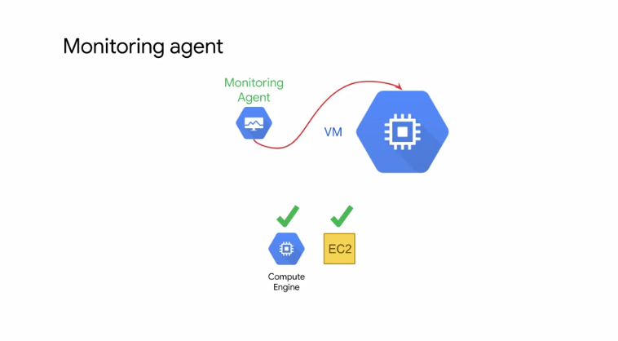

However, to access additional system resources and application services, you should install the monitoring agent. The monitoring agent is supported for Compute Engine and EC2 instances. The monitoring agent can be installed with these two simple commands. Which you could include in your startup script. This assumes that you have a VM instance running Linux that is being monitored by a workspace and that your instance has the proper credentials for the agent. If the standard metrics provided by Stackdriver monitoring do not fit your needs, you can create custom metrics. For example, imagine a game server that has a capacity of 50 users what metric indicator might you use to trigger scaling events. From an infrastructure perspective, you might consider using CPU load, or perhaps network traffic load, as values that are somewhat correlated with the number of users. But with a custom metric, you could actually pass the current number of users directly from your application into Stackdriver. To get started with creating custom metrics, see the link section of this video.

**Logging**

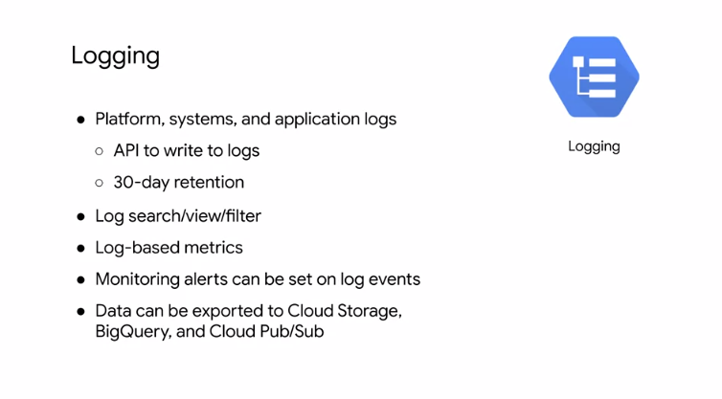

Monitoring is the basis of Stackdriver. But the service also provides logging, error reporting, tracing, and debugging. Let's learn about logging. Stackdriver logging allows you to store, search, analyze, monitor, and alert on logged data and events from GCP and AWS. It is a fully managed service that performs at scale, and can ingest application and system log data from thousands of VMs. Logging includes storage for logs, a user-interface called the logs viewer, and an API to manage logs programmatically. The service lets you read and write log entries, search and filter your logs, and create log-based metrics. Logs are only retained for 30 days, but you can export your logs to Cloud Storage buckets, BigQuery datasets, and Cloud Pub/Sub topics. Exporting logs to Cloud Storage makes sense for storing logs for more than 30 days. But why would you export to BigQuery or Cloud Pub/Sub? Exploiting logs to BigQuery allows you to analyze logs and even visualize them in Data Studio. BigQuery runs extremely fast SQL queries on gigabytes to petabytes of data. This allows you to analyze logs such as your network traffic so that you can better understand traffic growth to forecast capacity, network usage to optimize network traffic expenses, or network forensics to analyze incidence. For example, in this screenshot, I queried my logs to identify the top IP addresses that have exchange traffic with my web server. Depending on where these IP addresses are and who they belong to, I could relocate part of my infrastructure to save on networking costs, or deny some of these IP addresses if I don't want them to access my web server. If you want to visualize your logs, I recommend connecting your BigQuery tables to Data Studio. Data Studio transforms your raw data into the metrics and dimensions that you can use to create easy to understand reports and dashboards. I mentioned that you can also export logs to Cloud Pub/Sub. This enables you to stream logs to applications or endpoints. Similar to Stackdriver monitoring agent, it's a best practice to install the logging agent on all of your VM instances. The logging agent can be installed with these two simple commands, which you could include in your startup script. This agent is supported for Compute Engine and EC2 instances.

**Error Reporting**

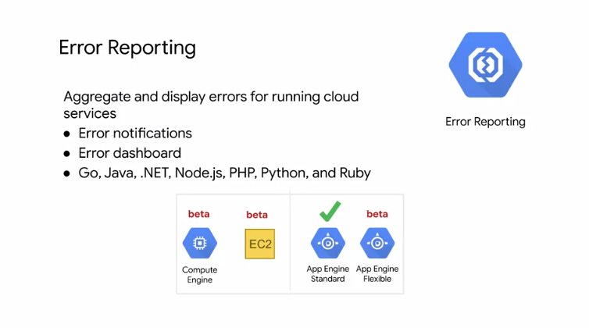

Let's learn about another feature of Stackdriver, Error Reporting. Stackdriver Error Reporting counts, analyses and aggregates the errors in your running Cloud services. A centralized Error Management interface displays the results with sorting and filtering capabilities and you can even set up real-time notifications when new errors are detected. As of this recording, Stackdriver Error reporting is generally available for the App Engine standard environment and is a better feature for App Engine flexible environment, Compute Engine and AWS EC2. In terms of programming languages, the exception stack trace parser is able to process Go, Java,.NET, Node.js, PHP, Python and Ruby. By the way, I'm mentioning App Engine because you will explore Error reporting in an app deployed to App Engine in the upcoming lab.

**Tracing**

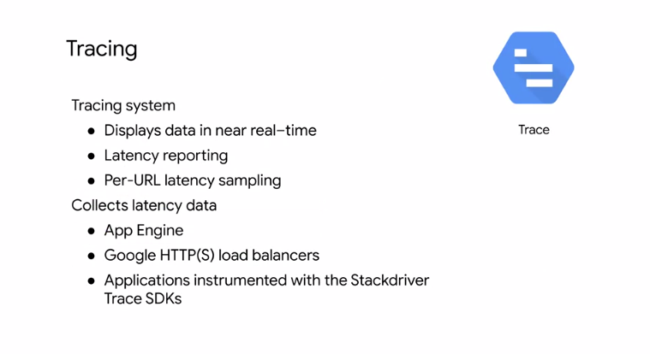

Tracing is another Stackdriver feature integrated into GCP. Stackdriver Trace is a distributed tracing system that collects **latency data** from your applications and displays it in the GCP console. You can track how request propagate through your application and receive detailed, near real-time performance insights. Stackdriver Trace automatically analyzes all of your application's traces to generate in-depth latency reports that surface performance degradations and can capture traces from App Engine, HTTP load balancers, and applications instrumented with the Stackdriver Trace API. Managing the amount of time it takes for your application to handle incoming requests and perform operations is an important part of managing overall application performance. Stackdriver Trace is actually based on the tools used at Google to keep our services running at extreme scale.

**Debugging**

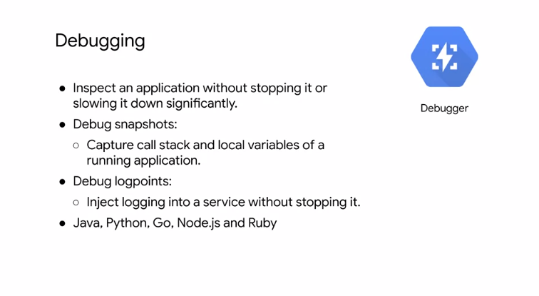

Finally, let's cover the last Stackdriver feature of this module, which is the Debugger. Stackdriver Debugger is a feature of GCP that lets you inspect the state of a running application in real time, without stopping or slowing it. Specifically, the Debugger adds less than 10 milliseconds to the request latency when the application state is captured. In most cases, this is not noticeable by users. These features allow you to understand the behavior of your code in production and analyze it state to locate those hard to find bugs. With just a few mouse clicks, you can take a snapshot of your running application state or inject a new logging statement. Stackdriver Debugger supports multiple languages including; Java, Python, Go, Node.js and Ruby.